

USER INTERFACE DESIGN LAB MANUAL

SUBMITTED BY:
NAME | J.Rudrateja
ROLL NO | AV.SC.U4CSE25114
COURSE | CSE
SECTION | B

SUBMITTED TO:
NAME | DR.RAJKUMAR BATCHU SIR
DESIGNATION | Assistant Professor (Sl. Gd.)

INDEX
S.NO | TITLE | PAGE NO: | REMARKS
1 | Week 1.:A.installation of vs code  B.Understanding basics of HTML  C.Understanding basics of HTML tags | 4-9
2 | Week 2.:A. desing a basic web page with heading ,paragraph,  table, by adding styles | 10-12
3 | Week 3.:A.Create class timetable using html elements  B.Create a html web page that should display syllabus  Of all the subjects as an image format and also, the  timetable | 13-24
4 | Week 4.:A.Design a registration form using only HTML tags (no  CSS) with proper labels, table alignment, background  color, and borders.  B.Two forms displayed side by side using iframes .one is  login and another registration | 24-31
5 | Week 5.:A.creating a card layout using <div> tag consider  three cards and a button using html and css  B.navigation using iframe (mini website) upon clicking  each buttons the details about that button should be  display on the same page  C.Design amrita login page by showing different  campus on home page.upon clicking on each campus  the details about each campus should be display on  the same page use html and css to design a stylish  webpage | 32-48
6 | Week 6:A. : Design a responsive e-commerce application using  the grid layout. This application should contain  different categories of products such as  electronics,clothing, home-appliances, books.  B: Design a responsive e-commerce application using  the grid layout. This application should contain  different categories of products such as electronics,  clothing, home-appliances, books. Based on the  category we select corresponding products should be  displayed on the sidebar. | 49-63
7 | Week 7:A.:create a GitHub account and create a repository in it  and push all the week 6 code files in it. | 64-66
8 | Week 8:A.:create a web page that displays a square that  continuously rotates 360 using css animation  B.:create a ball that moves up and down continuously  using css animation  C.:create a circle that moves horizontally and rotates  At the same time | 67-72
9 | Week 9:Create a webpage using html,css,js based on the give  conditions:  A:create a button for each program , based on the button  clicked the corresponding program has to be executed and  should didplay the output  B:the logics for each button includes finding an even or odd  number , prime or not , factorial of a number , Armstrong or not  C:use appropriate design to display the output | 73-77
10 | Week 10:A:write JavaScript conditional statement to find the sign  of product of three numbers using functions .Display  an alert box with specified sign  B:write a java script conditional statements to sort 3  numbers using functions display an alert box to show  the result  C:write a java script conditional statement to find largest of  find largest of five numbers using function and onclick  event .display an alert box to show the result  D:write a java script for loop that will iterate from 0 to 15.  For each iteration ,it will check if the current number  odd or even , and display a message on screen  E:write a java script program to read 6 subjects marks from  the student then computes the average marks of students  then , this average is used to determine the corresponding  grade. | 78-83
11 | Week 11:A. A website requires users to enter a username. The  system should display a message while typing if the  username is less than 5 characters.  B. A registration form should validate email format before  submission. If invalid, the form should not be submitted.  C. A system should check password strength while typing  and display whether it is weak or strong.  D. A form should validate a mobile number when the user  leaves the input field. The number must be exactly 10  digits.  E. Design an HTML page, such that the registration form  must validate:  Name (not empty)  Email (valid format)  Password (minimum 6 characters) | 83-93
12 | Week-12 : To show the steps involved in installing and  using electron. | 93-97

WEEK-1

1.Lab Setup
Aim: Installation of VS code tool
Procedure:
Step 1: Visit the Official Website of the Visual Studio Code using any web browser like Google Chrome, Microsoft Edge, etc.
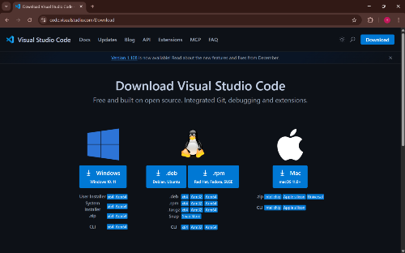
[Step 2]: Press the "Download for Windows" button on the website to start the download of the Visual Studio Code Application.
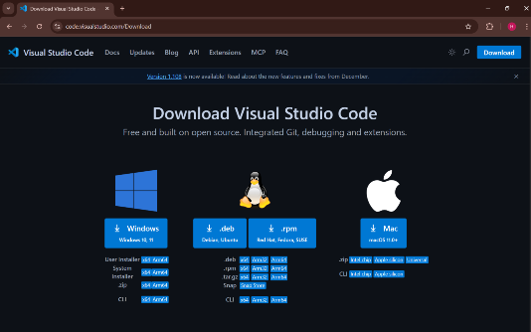

[Step3] When the download finishes, then the Visual Studio Code Icon appears in the downloads folder.

[Step4]Click on the Installer icon to start the installation process of the Visual Studio Code.
[Step5] After the Installer opens, it will ask you to accept the terms and conditions of the Visual Studio Code. Click on I accept the agreement and then click the Next button.
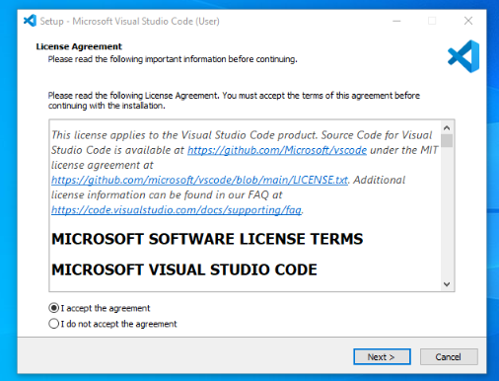
[Step6]:Choose the location data for running the Visual Studio Code. It will then ask you to browse the location. Then click on the Next button.
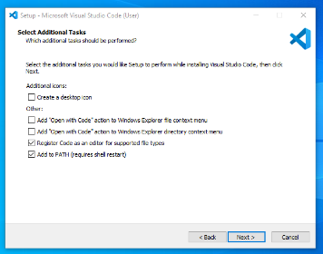
[Step7]Then it will ask to begin the installation setup. Click on the Install button. After clicking on Install, it will take about 1 minute to install the Visual Studio Code on your device.
After the Installation setup for Visual Studio Code is finished, it will show a window like this below. Tick the "Launch Visual Studio Code" checkbox and then click Next.
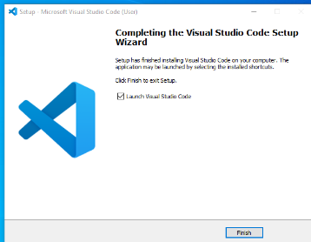

[Step 10]: After the previous step, the Visual Studio Code window opens successfully. Now you can create a new file in the Visual Studio Code window and choose a language of yours to begin your programming journey!
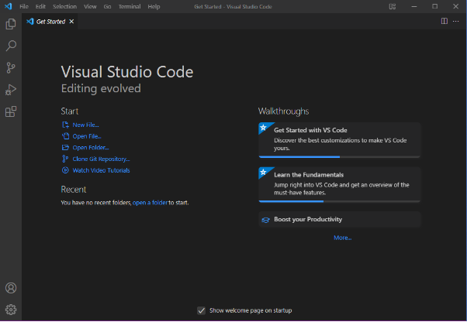
So this is how we successfully installed Visual Studio Code on our Windows system. The steps mentioned in the above guideline can be used in any kind of Windows Browsers for Downloading & Installation VS Code on Windows 10. So, try these steps to get the VS Code IDE on your device as well

2. Structure of HTML
Aim: To know the basic structue of HTML
Name: J.Rudrateja
Roll No: AV.SC.U4CSE25114
Department: CSE

Code:

<!DOCTYPE html>
<html>
<head>
<title>Page title</title>
</head>
<body>
<h1>This is heading</h1>
<p>This is a paragraph</p>
<p>Name: J.Rdrateja </p>
<p>Roll: AV.SC.U4CSE25114</p>
<p>Department: Computer Science Engineering</p>
<p>Section: CSE-B</p>
</body>
</html>

Output:
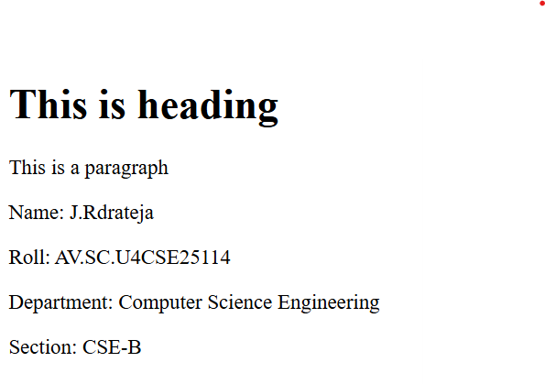

Explanation:
HTML gives the basic structure of a webpage.
Every HTML page starts with <!DOCTYPE html> to define the version.
The <html> tag is the root element containing all other tags.
The <head> section includes information like the page title.
The <body> section contains the visible content shown in the browser.
The following paragraph tags are used to display personal information:
Name
Roll number
Department
Section

3. Types of headings
Aim: To create a simple HTML web page that demonstrates the use of different heading tags from <h1> to <h6>.
Name: J.Rudrateja
Roll No: AV.SC.U4CSE25114
Department: CSE

Code:
<!DOCTYPE html>
<html>
<head>
<title>Headings</title>
</head>
<body>
<h1>This is heading 1</h1>
<h2>This is heading 2</h2>
<h3>This is heading 3</h3>
<h4>This is heading 4</h4>
<h5>This is heading 5</h5>
<h6>This is heading 6</h6>
<p>Name: J.Rudrateja</p>
<p>Roll: AV.SC.U4CSE25114</p>
<p>Department: CSE</p>
<p>Section: CSE-B</p>
</body>
</html>
Output:
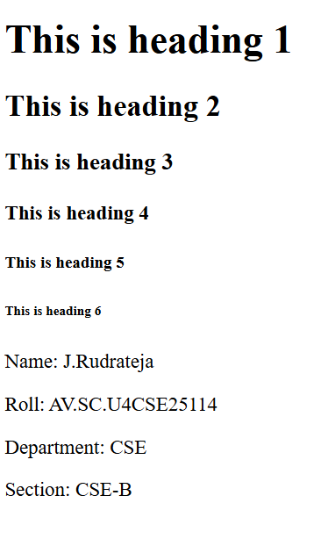

Explanation:
HTML provides six heading tags:
<h1> – Main Heading (Largest)
Represents the primary focus of the page, usually used for the main title.
Use only one <h1> tag per page for the best SEO practices.
Makes it clear to both users and search engines what the main topic is.
<h2> – Subheadings
Ideal for dividing the content into major sections.
If the content has further subsections, use <h3> to create a logical flow.
<h3> to <h6> – Smaller Headings
These heading levels are used for finer subdivisions, gradually decreasing in size and importance.
<h3> is used for subsections under <h2>, while <h4> to <h6> are used for additional, less important subdivisions.
<h6> defines the least important heading.

4. Using Line break tag
Aim: To create a simple HTML web page that demonstrates the use of the paragraph tag <p> and line break tag <br>.
Name: J.Rudrateja
Roll No: AV.SC.U4CSE25114
Department: CSE

Code:
<!DOCTYPE html>
<html>
<head>
<title>Paragraph</title>
</head>
<body>
<p>This isJ.Rudrateja.<br>I'm from Eluru.<br>I'm studying B.Tech.<br>Roll No.AV.SC.U4CSE25114</p>
</body>
</html>

Output:
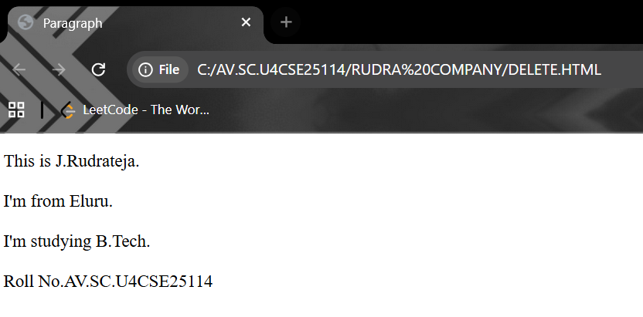

Explanation:

<br> — Line Break Tag
The <br> tag is used to break the line and move the text to the next line without starting a new paragraph.

5. Creating hyperlinks
Aim: To create a simple HTML web page that demonstrates how to use the anchor tag <a> to create hyperlinks.
Name: J.Rudrateja
Roll No: AV.SC.U4CSE25114
Department: CSE

Code:
<!DOCTYPE html>

<html>

<head>

<title>Links</title>

</head>

<bodyl>
<h1>My name J.Rudrateja</h1>
<p>I am from CSE-B section</p>
<p1>My roll no.is AV.SC.U4CSE25114</p1>
<p2>Here are some useful links</p2>
<a href="https://www.amrita.edu/">Amrita Vishwa Vidyapeetham</a><br>

<a href="https://toonstream.com">Toon Stream</a><br>

<a href="https://chatgpt.com">Chat GPT</a>

</bodyl>

</html>

Output:
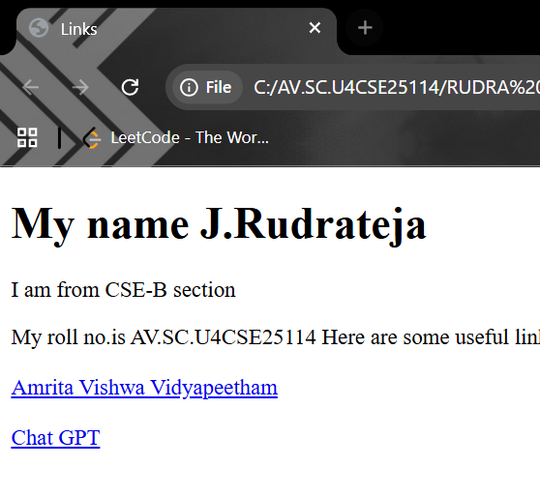

Explanation:

<a> ... </a> — Anchor Tag (Hyperlink)
The <a> tag is used to create hyperlinks. The href attribute contains the URL (web address) of the page to open.
<a href="https://www.amrita.edu/">Amrita Vishwa Vidyapeetham</a>
This creates a link to the Amrita website.
<a href="https://toonstream.com">Toon Stream</a>
This creates a link to the Toon Stream website.
<a href="https://chatgpt.com">Chat GPT</a>
This creates a link to the ChatGPT website.

6. To create a simple HTML web page that displays an image.
Aim: To create a simple HTML web page that displays an image using the <img> tag.
Name: J.Rudrateja
Roll No: AV.SC.U4CSE25114
Department: CSE
Code:
<!DOCTYPE html>
<html>
<head>
<title>Image</title>
</head>
<body>
<p>My name is J.Rudrateja<br>
<br>My roll number is AV.SC.U4CSE2514<br>
<br>I am from CSE-B section<br>
<br>Here is an image</p>
<img src="notnow.jpg" alt="Sample Image" width="500" height="600">
</body>
</html>

Output:

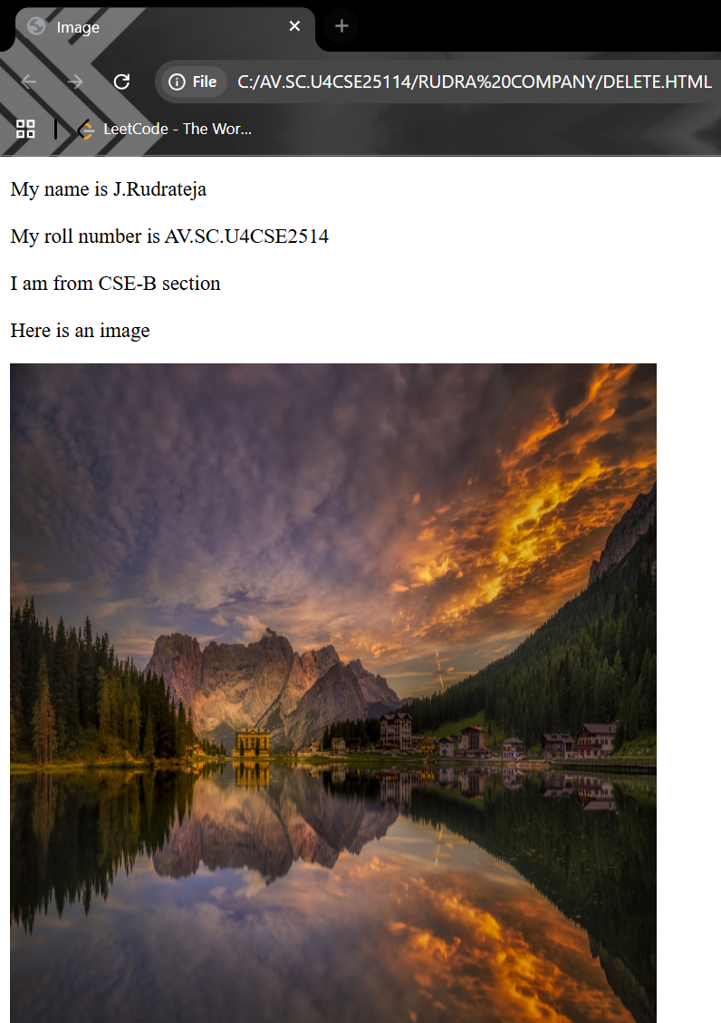

Explanation:
The HTML <img> tag is used to embed images in a web page. It is an empty or self-closing tag, meaning it doesn’t have a closing tag. It allows to display images from various sources, such as files on a website or URLs from other websites.
Supports local and external image sources.
Common attributes include src, alt, width, and height.
Does not contain any inner content.
7.Aim: To Understand Basic html tags
CODE: <!DOCTYPE html>
<html>
<head>
<title>LEARN HTML WITH ME</title>
</head>
<BODY style="background-color: aquamarine;">
<h1 style="color: chartreuse; text-align: centre; background-color: brown;">START WITH ME:</h1>
<p style="color: blueviolet; text-align: left; background-color: blanchedalmond;">learning html is very interesting and have a lot of fun;
<br>
<br>
By using below website links:<br> </p>
<img src="notnow.jpg" width="500px" height="500px">
<br>
<br>
<a style="color: antiquewhite; background-color: blueviolet;" href="www.youtube.com">click me to have fun</a>
<p style="color: red; text-align: left;background-color: black;">
now by using the link you might get an a about the tags of html.now,follow the link below.
</p>
<br>
<br>
<a href="www.google.com"> unlock more</a>
</BODY>
</html>

Output:
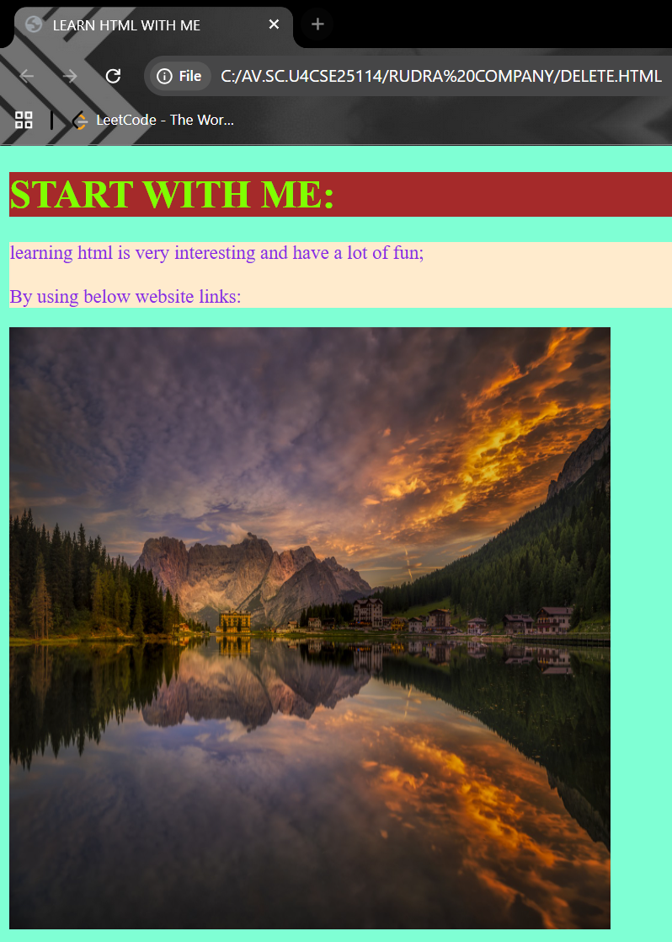

vExplanation:
<!DOCTYPE HTML>: tells that the doc type is html5
<html>: The element is the root element of an HTML page.
<head>: The element contains meta information about the HTML page
<title>: The <title> element specifies a title for the HTML page.
<body>: The <body> element contains all visible content like text images, link, tables, etc.
<h1>: the <h1> element defines a large heading
<p>: The <p> element defines a paragraph
<br>: it is used to break the lines
<img src=””>: it is used to add image
<a href=”” >: it is used to add link in the html website
Week3

Class Timetable
Aim: To make class Timetable
Name: J.Rudrateja
Roll no: AV.SC.U4CSE25114
Department:CSE
Code:
<!DOCTYPE html>
<html><style>
table,th,td{
border:2px solid black ;
border-collapse: collapse;

}
</style>
<head>
<title>Time table for CSE B section</title>
</head>
<body>
<h1 style="text-align:center; border:3px solid black;background-color:green; text-align: center;">CSE B SECTION TIMETABLE</h1>
<table border="3" align="center" width="100%" cellpadding="10" cellspacing="5" border-collapse="collapse">
<tr>
<th colspan="13" class="title">Master TimeTable CSE II Semester B Section</th>
</tr>
<tr>
<td colspan="6" class="left">Dept:Cse-B<br>Class:B-tech<br>Semester:II</td>
<td colspan="7" class="left">Dept:Cse-B<br>Class:B-tech<br>Semester:II</td>
</tr>
<tr>
<td colspan="6" class="left">Class advisors:Raghavendra narayan<br>Email:raghavendranarayan@gmail.com<br>Mobile number:7365275269</td>
<td colspan="7" class="left">Class advisors:Ankit sahu<br>Email:Ankitsahu@gmail.com<br>Mobile number:9876543210</td>
</tr>
<tr>
<td colspan="13" class="edge">Class Room venue:511</td>
</tr>

<tr>
<th>Time/Day</th>
<th>Slot 1<br>9:00-9:30</th>
<th>Slot 2<br>9:30-10:30</th>
<th class="yellow" rowspan="6">Short Break</th>
<th>Slot 3<br>10:45-11:30</th>
<th>Slot 4<br>11:30-12:45</th>
<th><style>
.yellow{
background-color: yellow;
font-weight:bolder;
}
</style>Slot5<br>12:45-1:15</th>
<th class="yellow" rowspan="6">Lunch Break</th>
<th>Slot 6</th>
<th class="yellow" rowspan="6">Short Break</th>
<th><style>
.yellow{
background-color: yellow;
font-weight:bolder;
}
</style>Slot 7</th>
<th>Slot 8</th>
</tr>
<tr>
<td>Monday</td>
<td colspan="2"><strong>Linear Algebra LAB</strong></td>
<td>Library</td>
<td>Calculus</td>
<td>Sports/Library</td>
<td >library</td>
<td>library</td>
<td>library</td>
</tr>

<tr>
<td>Tuesday</td>
<td>Disrete Mathematics</td>
<td>Linear Algebra</td>
<td>Modern Physics</td>
<td>Oriented programming</td>
<td>User interface Design</td>
<td>Library/sports</td>
<td>library</td>
<td>library</td>
</tr>
<tr>
<td>Wednesday</td>
<td colspan="2">Oriented programming</td>
<td>Library</td>
<td>Disrete Mathematics</td>
<td>Library</td>
<td>User interface Design Lab</td>
<td>library</td>
<td colspan="2">library</td>
</tr>
<tr>
<td>Thursday</td>
<td>Modern Physics</td>
<td>Disrete Mathematics</td>
<td>Linear Algebra</td>
<td>Glimpses of glorious India</td>
<td>Sports/Library</td>
<td>Oriented programming Lab</td>
<td colspan="4">Library</td>
</tr>
<tr>
<td>Friday</td>
<td colspan="2">User interface Design</td>
<td>Library</td>
<td>Modern Physics</td>
<td>Library</td>
<td>DisreteMathematics Lab</td>
<td colspan="4">Calculus</td>
</tr>
<tr>
<td cellpadding="4" cellspacing="2">Course code</td>
<td colspan="2">Couse name</td>
<td></td>
<td>L-T-P</td>
<td>Credits</td>
<td colspan="2">Faculty Name</td>
<td colspan="4">Assisting Faculty</td>
</tr>
<tr>
<td>MA201</td>
<td colspan="2">Disrete Mathematics</td>
<td></td>
<td>3-1-0</td>
<td>4</td>
<td colspan="2">Dr. K S Rajasekharan</td>
<td colspan="4">Ms. Anu Mary George</td>
</tr>
<tr>
<td>PH202</td>
<td colspan="2">Modern Physics</td>
<td></td>
<td>3-1-0</td>
<td>4</td>
<td colspan="2">Dr. R S Sreelakshmi</td>
<td colspan="4">Ms. Anu Mary George</td>
</tr>
<tr>
<td>CS202</td>
<td colspan="2">Oriented programming</td>
<td></td>
<td>3-0-2</td>
<td>4</td>
<td colspan="2">Dr. P Sreenivasa Kumar</td>
<td colspan="4">Ms. Anu Mary George</td>
</tr>
<tr>
<td>CS204</td>
<td colspan="2">User interface Design</td>
<td></td>
<td>3-0-2</td>
<td>4</td>
<td colspan="2">Dr. P Sreenivasa Kumar</td>
<td colspan="4">Ms. Anu Mary George</td>
</tr>
</table>
</body>
</html>

Output:
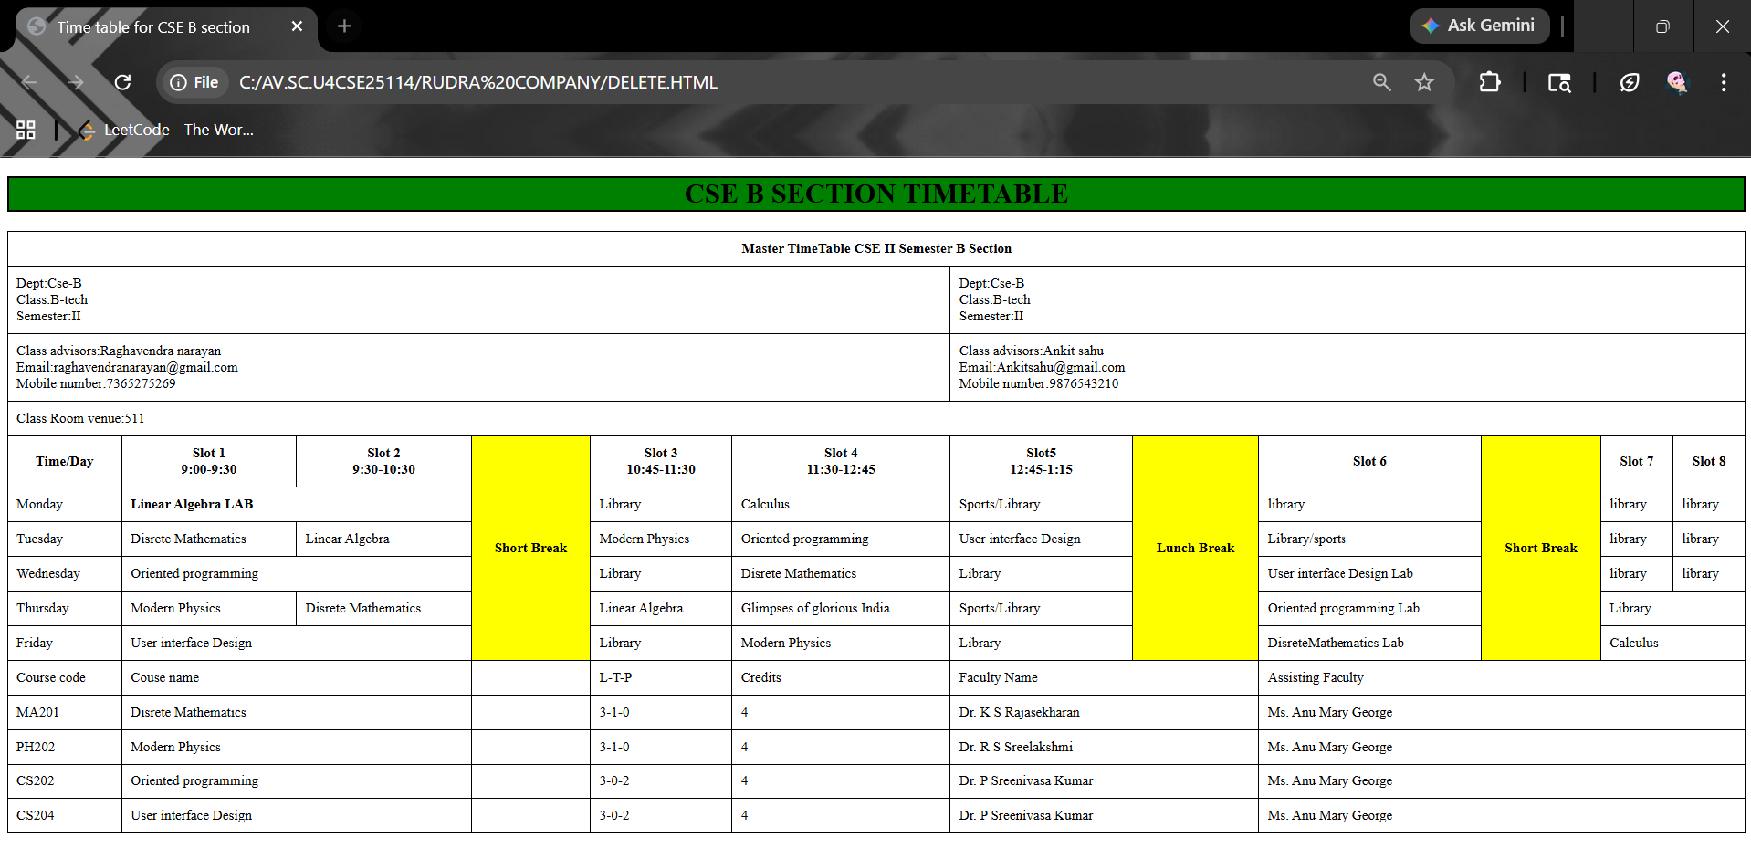
Explanation:
1. <table> Tag – Creating the Table:
This tag creates the main table.
border="1": adds border lines.
cellpadding="5": adds space inside cells.
cellspacing="10": adds space between cells.
align="center": places the table at the center.
bgcolor="white": sets background color.
2.<caption>:
The <caption> tag gives a title to the table.

3. <tr> – Table Row:
Each <tr> creates a new row in the table.
4. <th> – Table Heading:
<th> is used for header cells. Text inside <th> appears bold and centered.
5. colspan and rowspan:
These attributes merge cells.
Colspan: merges columns horizontally.
Rowspan: merges rows vertically.
6. <td> – Table Data:
<td> is used to insert normal data inside table cells such as:
A)Subjects
B)Days
C)Faculty names
D)Course codes
2. Syllabus
Aim: Syllabus
NameJ.Rudrateja
Roll No: AV.SC.U4CSE25114
Department: CSE
Code:
<!DOCTYPE html>
<html><style>
table,th,td{
border-collapse: collapse;
}
</style>
<head>
<title>SEM-II Syllabus</title>
<body style="background-color: beige;">
<p style="background-color: white;">Name:J.Rudrateja ; Roll No:AV.SC.U4CSE25114;</p>
<h1 style="text-align: center;">SEM-II Syllabus</h1>
<h2 style="text-align: left;"> Discrete Mathematics</h2>

<img src="Discrete Mathematics.jpg" width="500">

<h2 style="text-align: left;">Linear Algebra</h2>
<img src="Linear Algebra.jpeg" width="500">

<h2 style="text-align: left;">Object Oriented Programming</h2>
<img src="OOPS.jpeg" width="500">

<h2 style="text-align: left;">Modern Physics</h2>
<img src="Modern Physics.jpeg" width="500">

<h2 style="text-align: left;">User Interface Design</h2>
<img src="UID.jpeg" width="500">

<h2 style="text-align: left;">Manufacturing Practice</h2>
<img src="Manufacturing.jpeg" width="500">

<h2 style="text-align: left;">Glimpses of Glorious India</h2>
<img src="GGI.jpeg" width="500">

<h2 style="text-align: center;color: black;">Class Calender</h2>
<table border="1" cellspacing="0" cellpadding="1" width="90%" align="center" >

<table border="3" align="center" width="100%" cellpadding="10" cellspacing="5" border-collapse="collapse">
<tr>
<th colspan="13" class="title">Master TimeTable CSE II Semester B Section</th>
</tr>
<tr>
<td colspan="6" class="left">Dept:Cse-B<br>Class:B-tech<br>Semester:II</td>
<td colspan="7" class="left">Dept:Cse-B<br>Class:B-tech<br>Semester:II</td>
</tr>
<tr>
<td colspan="6" class="left">Class advisors:Raghavendra narayan<br>Email:raghavendranarayan@gmail.com<br>Mobile number:7365275269</td>
<td colspan="7" class="left">Class advisors:Ankit sahu<br>Email:Ankitsahu@gmail.com<br>Mobile number:9876543210</td>
</tr>
<tr>
<td colspan="13" class="edge">Class Room venue:511</td>
</tr>

<tr>
<th>Time/Day</th>
<th>Slot 1<br>9:00-9:30</th>
<th>Slot 2<br>9:30-10:30</th>
<th class="yellow" rowspan="6">Short Break</th>
<th>Slot 3<br>10:45-11:30</th>
<th>Slot 4<br>11:30-12:45</th>
<th><style>
.yellow{
background-color: yellow;
font-weight:bolder;
}
</style>Slot5<br>12:45-1:15</th>
<th class="yellow" rowspan="6">Lunch Break</th>
<th>Slot 6</th>
<th class="yellow" rowspan="6">Short Break</th>
<th><style>
.yellow{
background-color: yellow;
font-weight:bolder;
}
</style>Slot 7</th>
<th>Slot 8</th>
</tr>
<tr>
<td>Monday</td>
<td colspan="2"><strong>Linear Algebra LAB</strong></td>
<td>Library</td>
<td>Calculus</td>
<td>Sports/Library</td>
<td >library</td>
<td>library</td>
<td>library</td>
</tr>

<tr>
<td>Tuesday</td>
<td>Disrete Mathematics</td>
<td>Linear Algebra</td>
<td>Modern Physics</td>
<td>Oriented programming</td>
<td>User interface Design</td>
<td>Library/sports</td>
<td>library</td>
<td>library</td>
</tr>
<tr>
<td>Wednesday</td>
<td colspan="2">Oriented programming</td>
<td>Library</td>
<td>Disrete Mathematics</td>
<td>Library</td>
<td>User interface Design Lab</td>
<td>library</td>
<td colspan="2">library</td>
</tr>
<tr>
<td>Thursday</td>
<td>Modern Physics</td>
<td>Disrete Mathematics</td>
<td>Linear Algebra</td>
<td>Glimpses of glorious India</td>
<td>Sports/Library</td>
<td>Oriented programming Lab</td>
<td colspan="4">Library</td>
</tr>
<tr>
<td>Friday</td>
<td colspan="2">User interface Design</td>
<td>Library</td>
<td>Modern Physics</td>
<td>Library</td>
<td>DisreteMathematics Lab</td>
<td colspan="4">Calculus</td>
</tr>
<tr>
<td cellpadding="4" cellspacing="2">Course code</td>
<td colspan="2">Couse name</td>
<td></td>
<td>L-T-P</td>
<td>Credits</td>
<td colspan="2">Faculty Name</td>
<td colspan="4">Assisting Faculty</td>
</tr>
<tr>
<td>MA201</td>
<td colspan="2">Disrete Mathematics</td>
<td></td>
<td>3-1-0</td>
<td>4</td>
<td colspan="2">Dr. K S Rajasekharan</td>
<td colspan="4">Ms. Anu Mary George</td>
</tr>
<tr>
<td>PH202</td>
<td colspan="2">Modern Physics</td>
<td></td>
<td>3-1-0</td>
<td>4</td>
<td colspan="2">Dr. R S Sreelakshmi</td>
<td colspan="4">Ms. Anu Mary George</td>
</tr>
<tr>
<td>CS202</td>
<td colspan="2">Oriented programming</td>
<td></td>
<td>3-0-2</td>
<td>4</td>
<td colspan="2">Dr. P Sreenivasa Kumar</td>
<td colspan="4">Ms. Anu Mary George</td>
</tr>
<tr>
<td>CS204</td>
<td colspan="2">User interface Design</td>
<td></td>
<td>3-0-2</td>
<td>4</td>
<td colspan="2">Dr. P Sreenivasa Kumar</td>
<td colspan="4">Ms. Anu Mary George</td>
</tr>
</table>
</body>
</html>
Output:
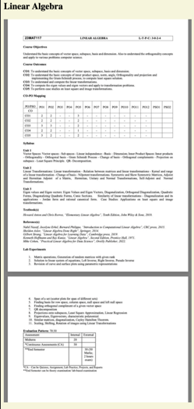
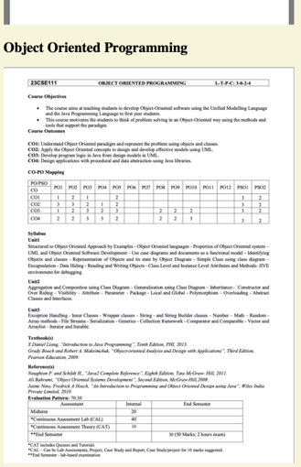
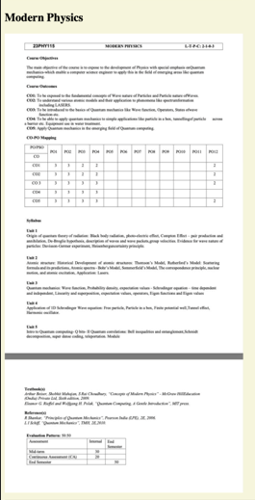
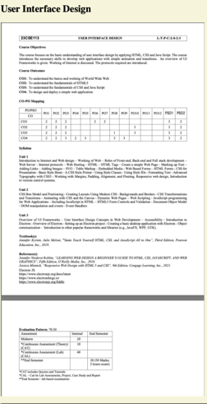
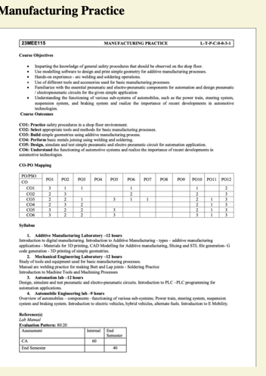

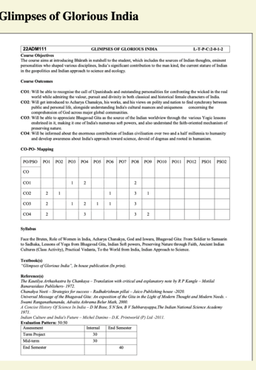
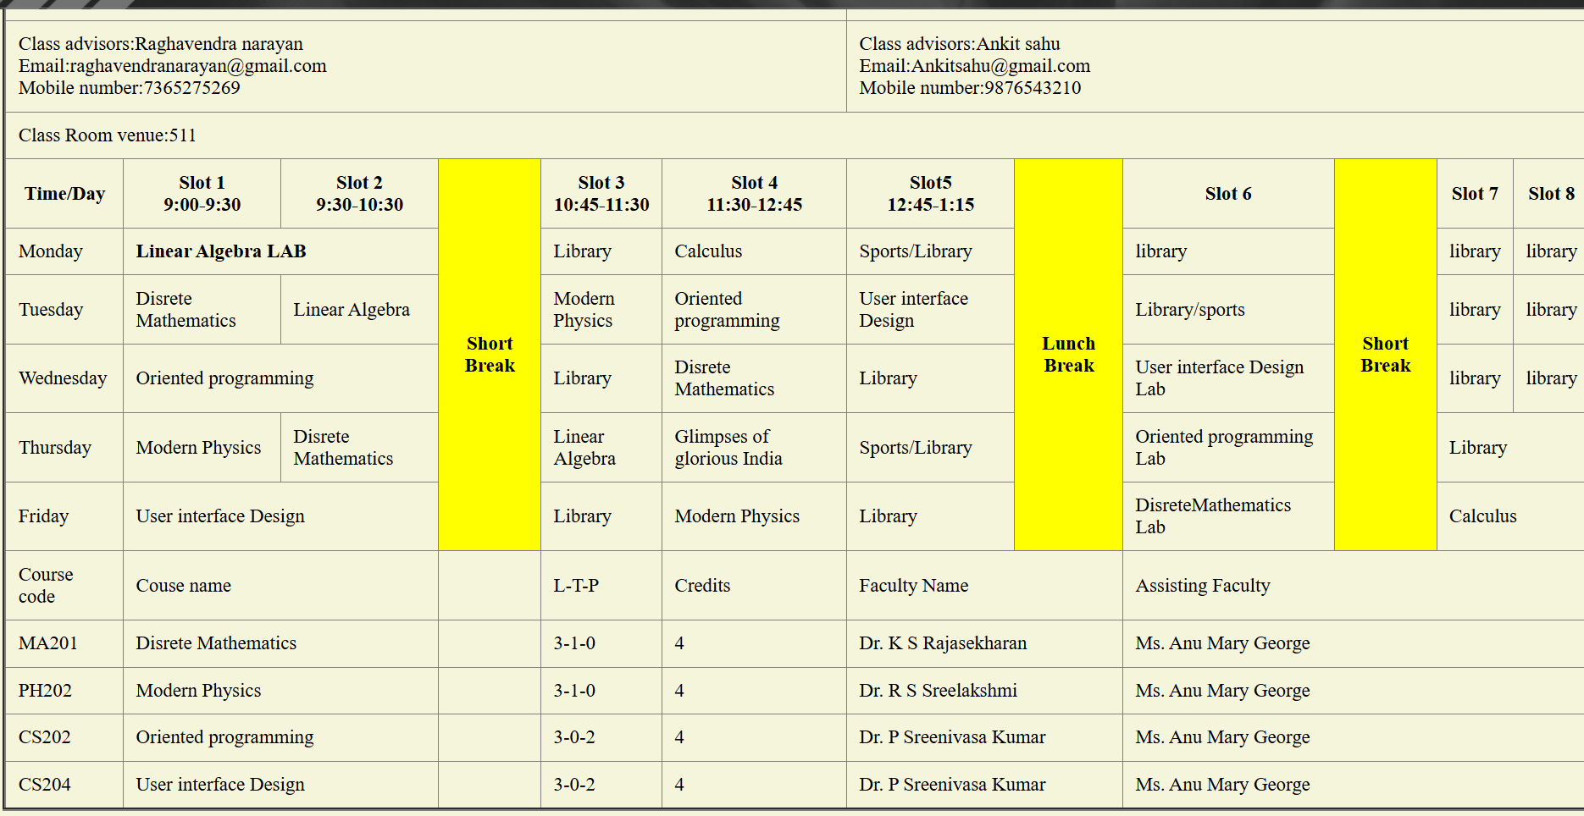
Explanation:
<!DOCTYPE html> tells the browser this is HTML5.
<html> is the root container of the whole webpage.
table, th, td → selects table and its cells
border-collapse: collapse → merges borders into single line
3. Head Section
<head>
<title>SEM-II Syllabus</title>
The head contains page metadata.
Title
<title> sets the browser tab name.
Your tab will show: SEM-II Syllabus

4. Body Section
<body style="background-color: beige;">
The body contains all visible content.
Here you set:
Background color = beige
So the whole page appears light beige.

5. Student Information
<p style="background-color: white;">
Name:J.Rudrateja Roll No:AV.SC.U4CSE25114
</p>
This creates a paragraph showing:
Student name
Roll number
The paragraph background is white.

6. Main Heading
<h1 style="text-align: center;">SEM-II Syllabus</h1>
<h1> is the biggest heading.
text-align: center puts it in the middle.
This is your page title.

7. Subject Headings
Example:
<h2 style="text-align: left;"> Discrete Mathematics</h2>
You repeat <h2> for each subject.
Purpose:
Shows subject names
Smaller than <h1>
Left aligned
Subjects listed:
Discrete Mathematics
Linear Algebra
Object Oriented Programming
Modern Physics
User Interface Design
Manufacturing Practice
Glimpses of Glorious India

8. Subject Images
Example:
<img src="Discrete Mathematics.jpg" width="500">
What happens:
Displays an image.
Width is fixed at 500 pixels.
Important behavior:
The browser will:
Look for the image file
Load it from the same folder
You placed one image for each subject.

9. Class Calendar Heading
<h2 style="text-align: center;color: black;">Class Calender</h2>
This introduces the timetable section.
Center aligned
Text color black

10. Table Creation
<table border="1" cellspacing="0" cellpadding="1" width="90%" align="center">
This creates the timetable table.
Attributes meaning
Attribute, Purpose
border="1", shows border
cellspacing="0", removes space between cells
cellpadding="1", space inside cells
width="90%", table takes 90% of page
align="center", table is centered

11. Table Headers
Example:
<tr>
<th>Time/Day</th>
<th>Slot 1<br>9:00-9:30</th>
Meaning
<tr> → table row
<th> → header cell (bold & centered)
<br> → line break inside cell
This row shows time slots.

12. Rowspan Usage (Vertical Merge)
Example:
<th class="yellow" rowspan="6">Short Break</th>
What happens
This cell stretches across 6 rows vertically.
Used to show break periods.
Very good use

13. Colspan Usage (Horizontal Merge)
Example:
<td colspan="2"><strong>Linear Algebra LAB</strong></td>
What happens
Cell covers 2 columns.
Used for lab periods

14. Yellow Break Styling
.yellow{
background-color: yellow;
font-weight:bolder;
}
This CSS class:
Colors cells yellow
Makes text bold
Used for:
Short Break
Lunch Break

15. Weekly Timetable Rows
Each day row:
<tr>
<td>Monday</td>
...
</tr>
Shows:
Day name
Subject in each time slot
Library / sports periods
Lab sessions
So the table becomes a full weekly schedule.

16. Course Information Section
Bottom rows show course details.
Example:
<td>MA201</td>
<td colspan="2">Disrete Mathematics</td>
<td>3-1-0</td>
<td>4</td>
Meaning of columns
Course code
Course name
L-T-P
Credits
Faculty
Assisting faculty
This acts like a course summary table.

17. End of Page
</body>
</html>
Closes body
Ends HTML document

WEEK-4

USER LOGIN WEBSITE BY USING HTML CODE
Code:
<!DOCTYPE html>
<html><style>
tabl,td{
border-collapse: collapse;
}
</style>
<body style="background-color: whitesmoke; align: center"></body>
<h1 style="text-align:center">Table registration form</h1>
<form>
<table border="1" cellpadding="10" cellspacing="0" bordercolor="black" align="center" style="background-color: yellowgreen">
<tr>
<td>Full Name:</td>
<td><input type="text"></td>
</tr>
<tr>
<td>Email:</td>
<td><input type="email"></td>
</tr>
<tr>
<td><label for="ph number"></label> Number:</td>
<td><input type="tel" name="ph number" id="ph number"></td>
</tr>
<tr>
<td><label for="gen">Gender</label></td>
<td><input type="radio" name="gen" id="gen">Male
<input type="radio" name="gen" id="gen">Female</td>
</tr>
<tr>
<td>Course:</td>
<td><select>
<option value="btech">B-Tech</option>
<option value="mtech">M-Tech</option>
<option value="Phd">PHD</option>
<option value="pd">PD</option>
</select></td>
</tr>
<tr>
<td><label for="ho">Hobbies</label></td>
<td><input type="checkbox" name="ho">Reading
<input type="checkbox" name="ho"> Travelling
<input type="checkbox" name="ho"> Writing</td>
</tr>
<tr>
<td><label for="date">Date of Birth</label></td>
<td><input type="date" name="date" id="date"></td>
</tr>
<tr>
<td><label for="up">Upload certificates</label></td>
<td><input type="file" name="up" id="up"></td>
</tr>
<tr>
<td>Address</td>
<td><textarea rows="4" cols="30"></textarea></td>
</tr>
<tr>
<td colspan="2" align="center"><input type="submit" value="Submit"></td>
</table>
</form>
</body>
</html>
Output:
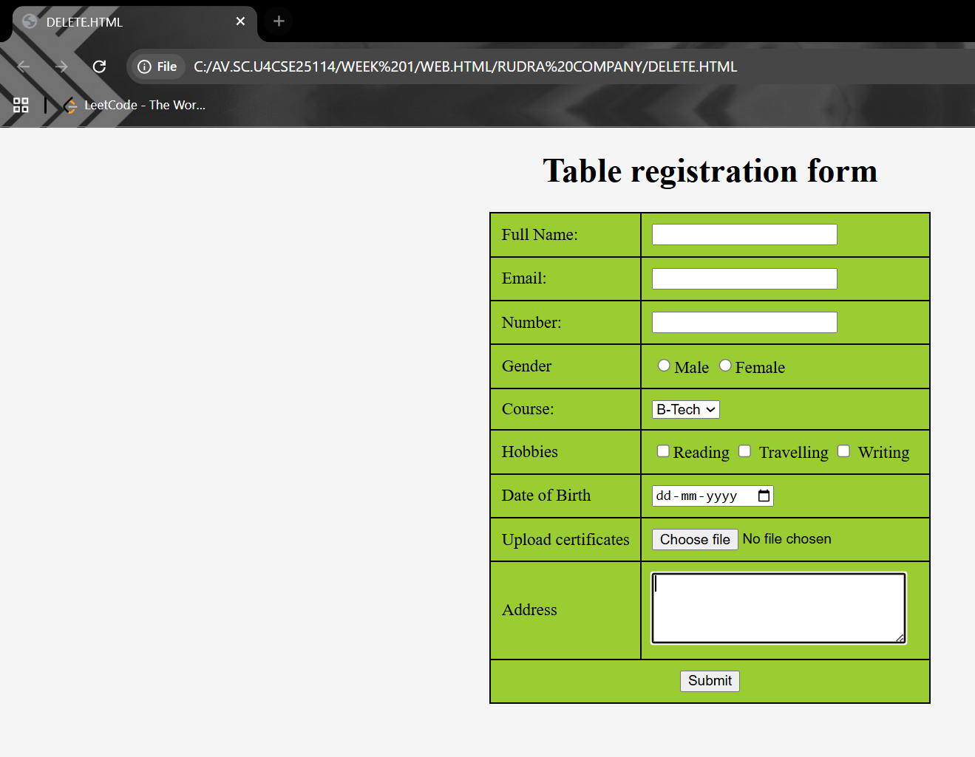

Explanation:
1. Document Type
<!DOCTYPE html>
Tells the browser this is an HTML5 document.

2. HTML Root
<html>
This is the root tag.
All HTML content must be inside <html>.

3. Head Section
<head>
<style>
table, td {
border: 1px solid black;
border-collapse: collapse;
}
</style>
</head>
What happens here:
<head> contains page settings.
<style> adds CSS.
CSS meaning:
Code, Purpose
table, td, Applies style to table and cells
border: 1px solid black, Adds border
border-collapse: collapse, Merges double borders into single line
Makes table look clean.

4. Body Tag
<body style="background-color: whitesmoke;">
Contains visible content of the webpage.
Inline CSS:
Sets page background to whitesmoke

5. Heading
<h1 style="text-align:center;">Table Registration Form</h1>
Displays the title of the form.
text-align:center → centers the heading.

6. Form Tag
<form>
Creates a form to collect user input.
Important: Without <form>, data cannot be submitted.

7. Table
<table cellpadding="10" cellspacing="0" align="center" style="background-color: yellowgreen;">
Used to arrange form fields neatly.
Attributes:
Attribute, Meaning
cellpadding="10", Space inside cells
cellspacing="0", Space between cells
align="center", Centers table
background-color, Table color

Form Fields Explained

Full Name
<input type="text" name="fullname">
Creates a text box for name input.

Email
<input type="email" name="email">
Creates email input.
Browser checks email format automatically.

Phone Number
<input type="tel" name="phnumber" id="phnumber">
Accepts telephone number.
id connects with label.

Gender (Radio Buttons)
<input type="radio" name="gender" id="male">
<input type="radio" name="gender" id="female">
Radio buttons allow only one selection.
Important rule:
Same name → single selection
Different id → unique identification

Course Dropdown
<select name="course">
<option value="btech">B-Tech</option>
Creates a dropdown list.
User selects one course.

Hobbies (Checkbox)
<input type="checkbox" name="hobbies">
Checkboxes allow multiple selections.
Difference:
Radio → one choice
Checkbox → many choices

Date of Birth
<input type="date" name="date">
Shows calendar picker.

File Upload
<input type="file" name="up">
Lets user upload certificates.

Address
<textarea rows="4" cols="30"></textarea>
Multi-line text box.
Used for long text.

Submit Button
<input type="submit" value="Submit">
Sends form data to server.

User login registration by using html
Code:
<!DOCTYPE html>
<html>
<body>
<div style="display:flex;gap:20px;border-radius: 4cqb;">
<iframe src="iframe.html" width="50%" height="300" style="float:left;"></iframe>
<iframe src="iframe2.html" width="50%" height="600"></iframe>
</div>
</form>
</body>
</html>
Output: 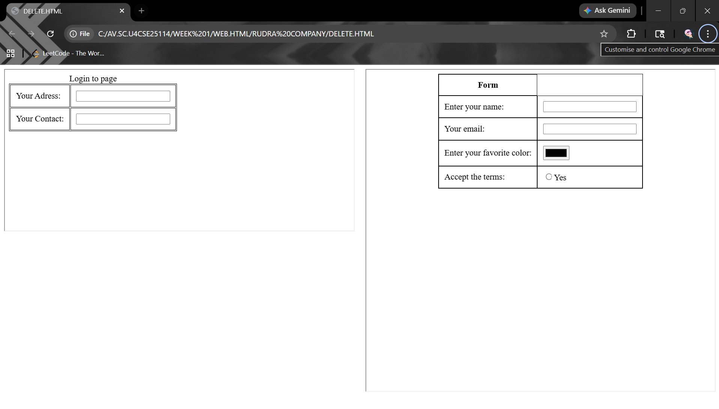

Explanation:
<!DOCTYPE html>
This tells the browser that the document is written in HTML5.
It helps the browser display the page correctly.

<html>
This is the root tag of the HTML document.
Everything in the webpage must be inside this tag.

<body>
This contains all the visible content of the webpage.

<div style="display:flex; gap:20px; border-radius: 4cqb;">
This is a container that holds the iframes
iframe src="iframe.html" width="50%" height="300" style="float:left;"></iframe>
This creates an embedded webpage inside your page.
iframe src="iframe2.html" width="50%" height="600"></iframe>
This loads another page.

Week 5
card using HTML and Css.
Programme:
<!DOCTYPE html>
<html>
<head>
<title style="text-align: center; color:#0b2a4a">AMRITA VISHWA VIDYAPEETAM CAMPUSES</title>
<style>

body {
background-image: url(https://images.pexels.com/photos/304664/pexels-photo-304664.jpeg);
background-size: cover; background-repeat: no-repeat;
display: flex;
justify-content: center;
align-items: center;
min-height: 100vh;

}
.cardcontainer {
display: flex;
justify-content: center;
align-items: center;
flex-wrap: wrap;
}
.card {
background-color: white;
width: 370px;
height: 370px;
border-radius: 10px;
box-shadow: 0 4px 8px rgba(0, 0, 0, 0.2);
display: flex;
flex-direction: column;
justify-content: center;
align-items: center;
margin: 20px;
}
.card img {
width: 270px;
height: 150px;
object-fit: cover;
border-radius: 10px;
margin-bottom: 15px;
}
.button {
background-color: #0b2a4a;
color: white;
padding: 10px 20px;
border: none;
border-radius: 5px;
cursor: pointer;
transition: 0.3s;
}
button:hover {
background-color: #144272;
}

</style>
</head>
<body>

<div class="cardcontainer">
<div class="card">
<h3 style="color:#0B3C5D ;"><b>Amrita Amritapuri</b></h3>
<img src="https://webfiles.amrita.edu/2014/02/Div8nr6Q-amritapuri-campus.jpg" alt="Amrita
University">
<p style="text-align: center; padding: 0 10px;">Amritapuri Campus, located in Kerala,
India.</p>
<button class="button"
onclick="window.location.href='https://www.amrita.edu/campus/amritapuri'">Visit Amritapuri Campus</button>

</div>
<div class="card">
<h3 style="color:#0B3C5D ;"><b>Amrita Amaravati</b></h3>
<img src="https://webfiles.amrita.edu/2024/10/amaravati-campus-banner.jpg" alt="Amrita
University">
<p style="text-align: center; padding: 0 10px;">Amaravati Campus, located in Andhra Pradesh,
India.</p>
<button class="button"
onclick="window.location.href='https://www.amrita.edu/campus/amaravati'">Visit Amaravati Campus</button>

</div>
<div class="card">
<h3 style="color:#0B3C5D ;"><b>Amrita Coimbatore</b></h3>
<img src="https://webfiles.amrita.edu/2020/06/hyKlkquw-790-100.jpg" alt="Amrita University">
<p style="text-align: center; padding: 0 10px;">Coimbatore Campus, located in Tamil Nadu,
India.</p>
<button class="button"
onclick="window.location.href='https://www.amrita.edu/campus/coimbatore'">Visit Coimbatore Campus</button>

</div>
</div>
</body>
</html>

Output:
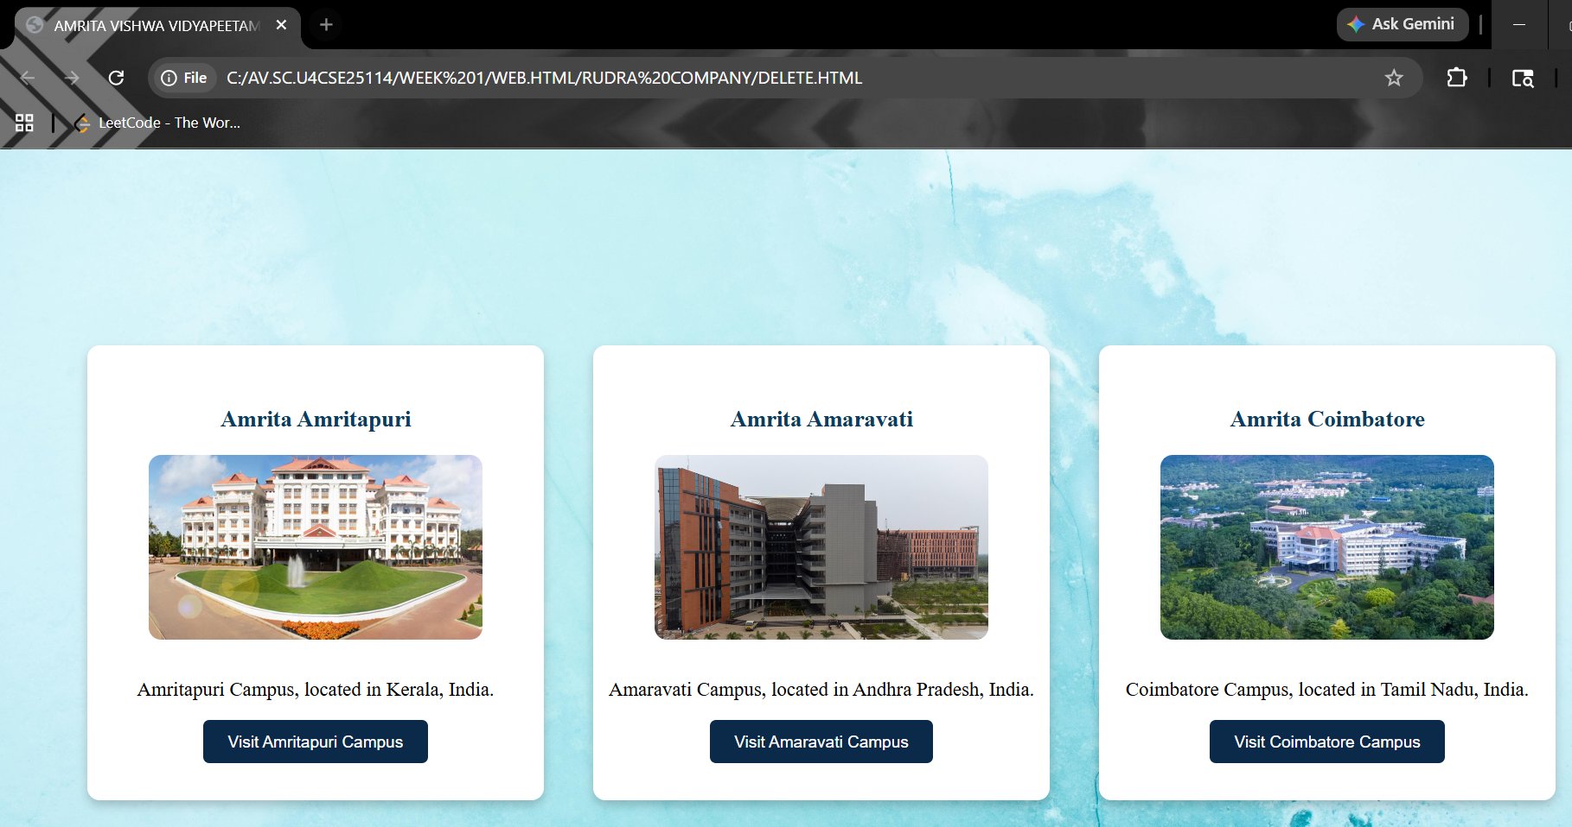
Explanation:
<DOCTYPE html> : the <!DOCTYPE html> element tells the web browser that this an
HTML document
or this is the latest version of HTML
<html> : the <html> element is the root element of an HTML web page
<head> : the <head> element will contain meta data about the HTML web page
<title> : the <title> element specifies a title for the HTML Page
<body> : the <body> element contains all visible content all visible content like text , image ,
links ,
tables , etc
<h> : we used <h> element for heading
<p> : we used <p> element for the paragraph
<div>:we use <div> element for encapsulating the the divisions and easy to modify and
<button>: we use <button> element for button
<img>: we use <img> tag for displaying the image
And we internal css for the html page and use element and class selector to apply the css to the
div elements and src attribute for image path ,by using the class and internal css we created this webpage
5(b):
Aim: Navigation using iframe (mini website) upon clicking each buttons the
details about that button should be display on the same page
code:
<!DOCTYPE html>
<html>
<head>
<title>RUDRATEJA JALASUTRAM</title>
<style>
body{
margin:0;
font-family:Arial;
background-color:#F4F6F8;
}
h1{
text-align:center;
background:#1F3A5F;
color:white;
padding:20px;
margin:0;
}
.menu{
background:#2C3E50;
padding:15px;
text-align:center;
}
.menu a{
color:white;
margin:0 15px;
text-decoration:none;
background:pink;
padding:10px 15px;
border-radius:5px;
}
.menu a:hover{
background:rgb(0, 162, 255);
}
iframe{
width:100%;
height:400px;
border:none;
}
</style>
</head>
<body>
<h1>JALASUTRAM RUDRATEJA</h1>
<div class="menu">
<a href="personality.html" target="frame">Strengths & Weaknesses</a>
<a href="goals.html" target="frame">Personal Info</a>
<a href="contribution.html" target="frame">Contributions</a>
</div>
<iframe name="frame"></iframe>
</body>
</html>
Output:
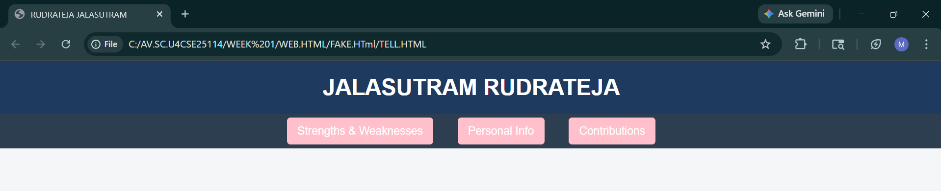
Personality.html:
<!DOCTYPE html>
<html>
<head>
<style>
body{font-family:Arial;text-align:center;}
.box{ border:2px solid black; padding:20px; display:inline-block;}
h2{color:#b91c1c;}
</style>
</head>
<body>
<div class="box">
<h2>My personality:</h2>
<p><ul>
<li>Strong willingness to learn new things</li>
<li>Good discipline and consistency</li>
<li>Ability to stay focused on goals</li>
<li>Quick learner and adaptable</li>
<li>Good teamwork and communication skills</li>
<li>Positive attitude even in difficult situations</li>
<li>Time management skills</li>
<li>Problem-solving mindset</li>
<li>Hardworking and dedicated</li>
<li>Self-motivated</li>
</ul></p>
</div>
</body>
</html>
Output:
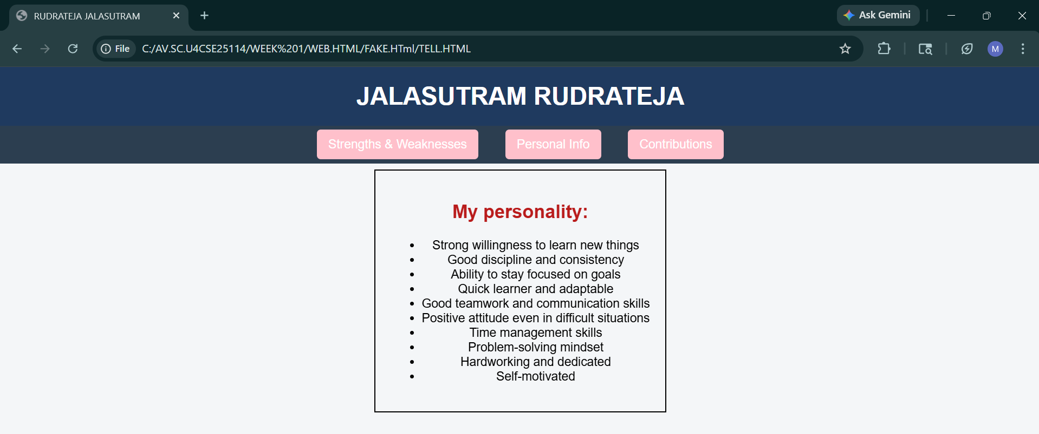

Contribution.html:
<!DOCTYPE html>
<html>
<head>
<style>
body{font-family:Arial;text-align:center;}
.box{ border:2px solid black; padding:20px; display:inline-block;}
h2{color:#b91c1c;}
</style>
</head>
<body>
<div class="box">
<h2>My contribution towards society:</h2>
<p>I take pride in my achievements, which reflect my dedication and continuous effort to improve myself. Throughout my journey, I have consistently worked hard in both academics and personal development. I have successfully managed my time to balance studies, skill-building, and fitness, which has helped me grow into a disciplined and focused individual. I have also taken initiative in learning new concepts and improving my abilities, which has strengthened my confidence and problem-solving skills. My achievements may not only be in results but also in the progress I have made, the challenges I have overcome, and the mindset I have developed to keep moving forward and striving for excellence.</p>
</div>
</body>
</html>
Output:
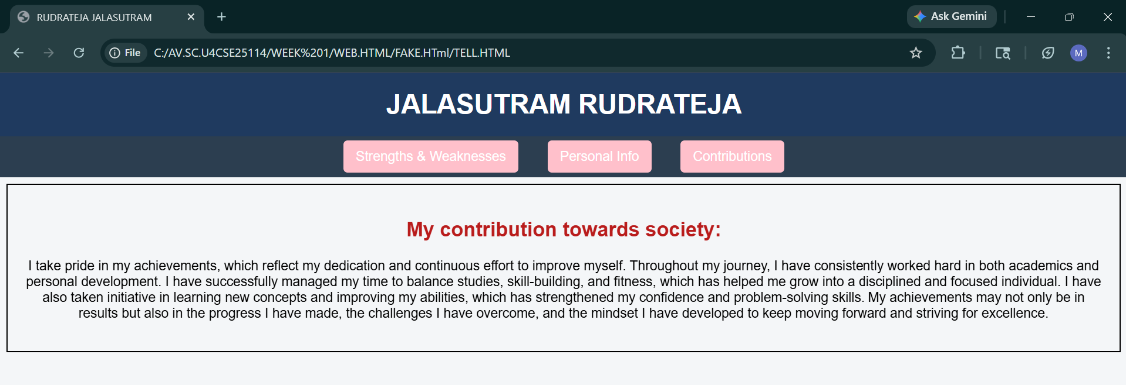
Goals.html:
<!DOCTYPE html>
<html>
<head>
<style>
body{font-family:Arial;text-align:center;}
.box{ border:2px solid black; padding:20px; display:inline-block;}
h2{color:#b91c1c;}
</style>
</head>
<body>
<div class="box">
<h2>Strengths and Weaknesses</h2>
<p>My name is J. Rudrateja. I am a motivated and hardworking individual with a strong desire to learn and grow both personally and professionally. I am known for my positive attitude, discipline, and ability to stay focused on my goals. I enjoy taking on new challenges and continuously improving my skills. I work well both independently and as part of a team, and I always strive to give my best in every task I take up. I am also committed to self-development and believe in maintaining consistency, whether it is in academics, career, or personal fitness.</p>
</div>
</body>
</html>
Output:
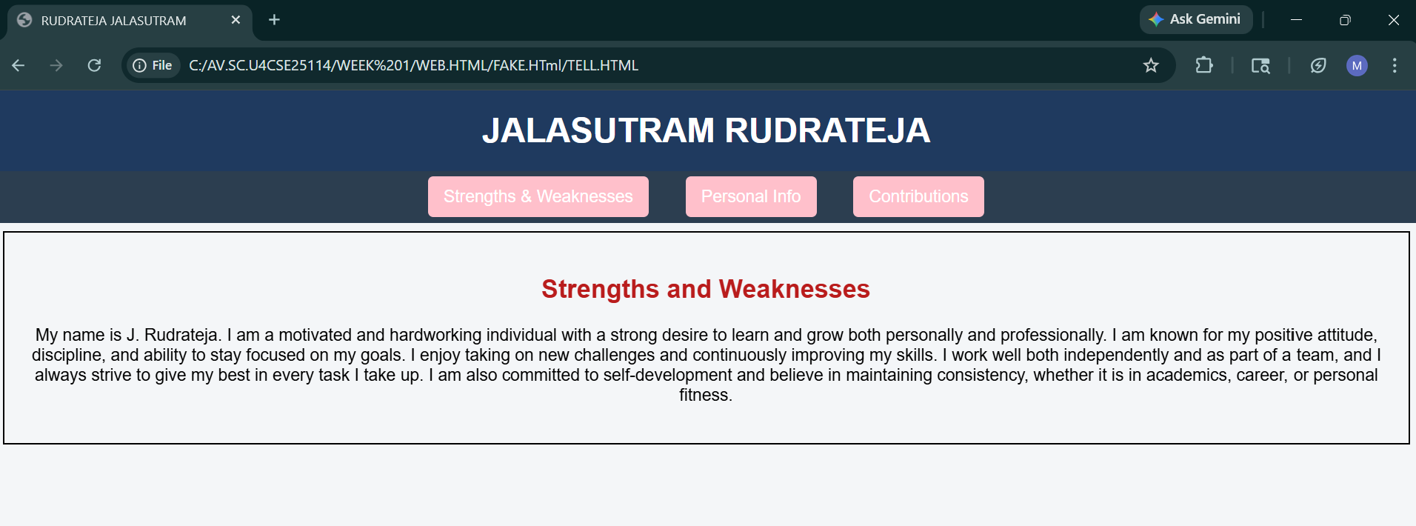
Explanation:
<DOCTYPE html> : the <!DOCTYPE html> element tells the web browser that this an
HTML document
or this is the latest version of HTML
<html> : the <html> element is the root element of an HTML web page
<head> : the <head> element will contain meta data about the HTML web page
<title> : the <title> element specifies a title for the HTML Page
<body> : the <body> element contains all visible content all visible content like text , image ,
links ,
tables , etc
<h> : we used <h> element for heading
<p> : we used <p> element for the paragraph
<div>:we use <div> element for encapsulating the the divisions and easy to modify and
<button>: we use <button> element for button
<img>: we use <img> tag for displaying the image
We used different types of input attributes for different inputs
And we internal css for the html page and use element and class selector to apply the css to the
div elements and src attribute for image path ,by using the class and internal css we created
this webpage and href attribute is used to link the html pages to the main webpage and use
target attribute to link the anchor element to href attribute . and the three webpages are linked
to main webpage and inline attribute for the border to wrap around it .

week 6
Aim: Design a responsive e-commerce application using the grid layout. This application
should contain different categories of products such as electronics, clothing, home-appliances,
books. Based on the category we select corresponding products should be displayed on the sidebar.
CODE:
(MAIN)
<!DOCTYPE html>
<html lang="en">
<head>
<meta charset="UTF-8">
<meta name="viewport" content="width=device-width, initial-scale=1.0">
<title>UNDEFINED STUDIOS</title>
<style>
body {
margin: 0;
padding: 0;
font-family: 'Segoe UI', Roboto, Helvetica, Arial, sans-serif;
color: white;
min-height: 100vh;
}

.background-video {
position: fixed;
top: 0;
left: 0;
width: 100%;
height: 100%;
object-fit: cover;
z-index: -1;
}

.main {
display: grid;
grid-template-areas:
"header header"
"sale sale"
"categories display"
"footer footer";
grid-template-columns: 300px 1fr;
gap: 20px;
padding: 20px;
}

.header, .sale, .categories, .footer {
background: rgba(255, 255, 255, 0.1);
backdrop-filter: blur(15px);
border: 1px solid rgba(255, 255, 255, 0.2);
border-radius: 15px;
box-shadow: 0 8px 32px 0 rgba(0, 0, 0, 0.3);
padding: 20px;
}

.header {
grid-area: header;
text-align: center; }

.sale {
grid-area: sale;
text-align: center;
font-size: 14px;
color: #adff2f;
text-transform: uppercase;
letter-spacing: 2px;
}

.categories {
grid-area: categories;
}

.categories h2 {
border-bottom: 2px solid rgba(255,255,255,0.2);
padding-bottom: 10px;
}

.categories p {
padding: 12px;
margin: 5px 0;
border-radius: 8px;
cursor: pointer;
transition: 0.3s;
}

.categories p:hover {
background: rgba(255, 255, 255, 0.15);
}

.categories p:hover{
transform: scale(1.05);
transition: transform 0.5s ease;
}

.footer {
grid-area: footer;
display: flex;
justify-content: space-around;
flex-wrap: wrap;
margin-top: 20px;
color: #eee;
}

.footer-col {
flex: 1;
min-width: 200px;
padding: 10px;
}

.footer a {
color: #00e5ff;
text-decoration: none;
}

.footer a:hover {
text-decoration: underline;
}

iframe {
width: 100%;
height: 100%;
min-height: 715px;
border: none;
border-radius: 15px;
background: rgba(255, 255, 255, 0);
}

.display{
grid-area: display;
width: 100%;
height: 100%;
}

.categories a {
color: white;
text-decoration: none;
}

@media screen and (max-width: 768px) {
.main {
grid-template-areas:
"header"
"sale"
"categories"
"display"
"footer";
grid-template-columns: 1fr;
}

.categories {
width: auto;
}

iframe {
min-height: 550px;
}
}

</style>
</head>
<body>

<video autoplay loop muted playsinline class="background-video">
<source src="212404.mp4" type="video/mp4">
</video>

<div class="main">
<header class="header">
<h1>E Commonication</h1>
</header>

<div class="sale">
<strong>Learn communication</strong>
</div>

<div class="categories">
<h2>Categories</h2>
<a href="technical.html" target="content-frame"><p>Technical</p></a>
<a href="specialization.html" target="content-frame"><p>Specializations</p></a>
<a href="core.html" target="content-frame"><p>Core Courses</p></a>
<a href="nontech.html" target="content-frame"><p>Non-Technical</p></a>
<a href="business.html" target="content-frame"><p>Business Courses</p></a>
</div>

<section class="display">
<iframe name="content-frame" src="technical.html"></iframe>
</section>

<footer class="footer">
<div class="footer-col">
<img src="" width="160" alt="Logo">
<p>Contact: support@edumongo.com</p>
</div>
<div class="footer-col">
<h4>Developer</h4>
<p>RUDRA TEJA JALASUTRAM<br>ID: CSE25114<br>Section: CSE-B</p>
</div>
<div class="footer-col">
<h4>Quick Links</h4>
<a href="https://github.com/rudra25114/UID-LAB-AV.SC.U4CSE25114.git">GitHub</a><br>
<a href="https://www.instagram.com/rudratejajalasutram/?__pwa=1#">Instagram</a><br>
8143819211
</div>
<div class="footer-col">
<h4>Address</h4>
<p>Amrita University, Amaravati, 522240</p>
<p>&copy; 2026 UNDEFINED</p>
</div>
</footer>
</div>

</body>
</html>

Business Courses:
<!DOCTYPE html>
<html>
<head>
<meta charset="UTF-8">
<meta name="viewport" content="width=device-width, initial-scale=1.0">
<style>
body {
margin:0;
padding: 0;
font-family: 'Segoe UI', Roboto, Helvetica, Arial, sans-serif;
color: white;
min-height: 100vh;
}

.display {
grid-area: display;
display: grid;
grid-template-columns: repeat(auto-fit, minmax(300px, 1fr));
gap: 20px;
}

.course-card {
padding: 0%;
text-align: center;
transition: transform 0.3s ease;
cursor: pointer;
overflow: hidden;
}

.course-card:hover {
transform: translateY(-8px);
background: rgba(255, 255, 255, 0.2);
}

.course-card img {
width: 100%;
border-top-left-radius: 10px;
border-top-right-radius: 10px;
margin-bottom: 10px;
transition: transform 0.5s ease;
display: block;
}

.course-card:hover img {
transform: scale(1.1);
}

.price{
display: flex;
justify-content: center;
align-items: center;
gap: 10px;
}

.course-card{
background: rgba(255, 255, 255, 0.1);
backdrop-filter: blur(15px);
border: 1px solid rgba(255, 255, 255, 0.2);
border-radius: 15px;
box-shadow: 0 8px 32px 0 rgba(0, 0, 0, 0.3);
}

s{
color: red;
}
</style>
</head>
<body>
<section class="display">
<div class="course-card"><img src="rich dad poor dad.jpg"><p>Rich Dad Poor Dad</p><div class="price"><p>₹450</p><s><strong>₹550</strong></s></div><p><strong>Course time: </strong>2 Weeks</p><div><button>Add to cart</button></div></div>
<div class="course-card"><img src="The power.jpg"><p>The Power of Subconcious Mind</p><div class="price"><p>₹450</p><s><strong>₹550</strong></s></div><p><strong>Course time: </strong>2 Weeks</p><div><button>Add to cart</button></div></div>
<div class="course-card"><img src="One Indian Girl.jpg"><p>One Indian Girl</p><div class="price"><p>₹699</p><s><strong>₹899</strong></s></div><p><strong>Course time: </strong>3 Weeks</p><div><button>Add to cart</button></div></div>
<div class="course-card"><img src="400 days.jpg"><p>400 Days</p><div class="price"><p>₹499</p><s><strong>₹650</strong></s></div><p><strong>Course time: </strong>2 Weeks</p><div><button>Add to cart</button></div></div>
</section>
</body>
</html>
Specialisation code:
<!DOCTYPE html>
<html>
<head>
<meta charset="UTF-8">
<meta name="viewport" content="width=device-width, initial-scale=1.0">
<style>
body {
margin:0;
padding: 0;
font-family: 'Segoe UI', Roboto, Helvetica, Arial, sans-serif;
color: white;
min-height: 100vh;
}

.display {
grid-area: display;
display: grid;
grid-template-columns: repeat(auto-fit, minmax(300px, 1fr));
gap: 20px;
}

.course-card {
padding: 0%;
text-align: center;
transition: transform 0.3s ease;
cursor: pointer;
overflow: hidden;
}

.course-card:hover {
transform: translateY(-8px);
background: rgba(255, 255, 255, 0.2);
}

.course-card img {
width: 100%;
border-top-left-radius: 10px;
border-top-right-radius: 10px;
margin-bottom: 10px;
transition: transform 0.5s ease;
display: block;
}

.course-card:hover img {
transform: scale(1.1);
}

.price{
display: flex;
justify-content: center;
align-items: center;
gap: 10px;
}

.course-card{
background: rgba(255, 255, 255, 0.1);
backdrop-filter: blur(15px);
border: 1px solid rgba(255, 255, 255, 0.2);
border-radius: 15px;
box-shadow: 0 8px 32px 0 rgba(0, 0, 0, 0.3);
}
</style>
</head>
<body>
<section class="display">
<div class="course-card"><A href="www.w3school.com"><p>PYTHON</p><div class="price"><p>₹450</p><s><strong>₹550</strong></s></div><p><strong>Course time: </strong>2 Weeks</p><div><button>Add to cart</button></div></div>
<div class="course-card"><A href="www.w3school.com"><p>JAVA</p><div class="price"><p>₹450</p><s><strong>₹550</strong></s></div><p><strong>Course time: </strong>2 Weeks</p><div><button>Add to cart</button></div></div>
</section>
</body>
</html>
Core(code):
<!DOCTYPE html>
<html>
<head>
<meta charset="UTF-8">
<meta name="viewport" content="width=device-width, initial-scale=1.0">
<style>
body {
margin:0;
padding: 0;
font-family: 'Segoe UI', Roboto, Helvetica, Arial, sans-serif;
color: white;
min-height: 100vh;
}

.display {
grid-area: display;
display: grid;
grid-template-columns: repeat(auto-fit, minmax(300px, 1fr));
gap: 20px;
}

.course-card {
padding: 0%;
text-align: center;
transition: transform 0.3s ease;
cursor: pointer;
overflow: hidden;
}

.course-card:hover {
transform: translateY(-8px);
background: rgba(255, 255, 255, 0.2);
}

.course-card img {
width: 100%;
border-top-left-radius: 10px;
border-top-right-radius: 10px;
margin-bottom: 10px;
transition: transform 0.5s ease;
display: block;
}

.course-card:hover img {
transform: scale(1.1);
}

.price{
display: flex;
justify-content: center;
align-items: center;
gap: 10px;
}

.course-card{
background: rgba(255, 255, 255, 0.1);
backdrop-filter: blur(15px);
border: 1px solid rgba(255, 255, 255, 0.2);
border-radius: 15px;
box-shadow: 0 8px 32px 0 rgba(0, 0, 0, 0.3);
}

s{
color: red;
}
</style>
</head>
<body>
<section class="display">
<div class="course-card"><A href="www.w3school.com"><p>MECHINE LEARNING</p><div class="price"><p>$48</p><s><strong>$55</strong></s></div><p><strong>Course time: </strong>2 Weeks</p><div><button>Add to cart</button></div></div>
<div class="course-card"><A href="www.w3school.com"><p>FULL STACK</p><div class="price"><p>$45</p><s><strong>$50</strong></s></div><p><strong>Course time: </strong>2 Weeks</p><div><button>Add to cart</button></div></div>
</section>
</body>
</html>
NON TECHNICAL:
<!DOCTYPE html>
<html>
<head>
<meta charset="UTF-8">
<meta name="viewport" content="width=device-width, initial-scale=1.0">
<style>
body {
margin:0;
padding: 0;
font-family: 'Segoe UI', Roboto, Helvetica, Arial, sans-serif;
color: white;
min-height: 100vh;
}

.display {
grid-area: display;
display: grid;
grid-template-columns: repeat(auto-fit, minmax(300px, 1fr));
gap: 20px;
}

.course-card {
padding: 0%;
text-align: center;
transition: transform 0.3s ease;
cursor: pointer;
overflow: hidden;
}

.course-card:hover {
transform: translateY(-8px);
background: rgba(255, 255, 255, 0.2);
}

.course-card img {
width: 100%;
border-top-left-radius: 10px;
border-top-right-radius: 10px;
margin-bottom: 10px;
transition: transform 0.5s ease;
display: block;
}

.course-card:hover img {
transform: scale(1.1);
}

.price{
display: flex;
justify-content: center;
align-items: center;
gap: 10px;
}

.course-card{
background: rgba(255, 255, 255, 0.1);
backdrop-filter: blur(15px);
border: 1px solid rgba(255, 255, 255, 0.2);
border-radius: 15px;
box-shadow: 0 8px 32px 0 rgba(0, 0, 0, 0.3);
}

s{
color: red;
}
</style>
</head>
<body>
<section class="display">
<div class="course-card"><img src="nt.jpg"><p>MATHEMATICS</p><div class="price"><p>$48</p><s><strong>$55</strong></s></div><p><strong>Course time: </strong>2 Weeks</p><div><button>Add to cart</button></div></div>
<div class="course-card"><img src="dh.jpg"><p>SCIENCE</p><div class="price"><p>$45</p><s><strong>$50</strong></s></div><p><strong>Course time: </strong>2 Weeks</p><div><button>Add to cart</button></div></div>
</section>
</body>
</html>
OUTPUT:
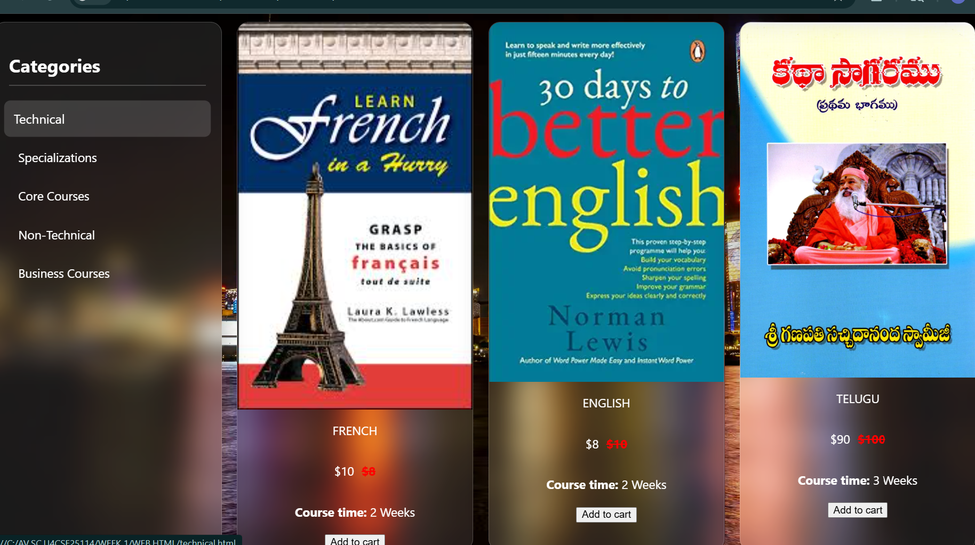
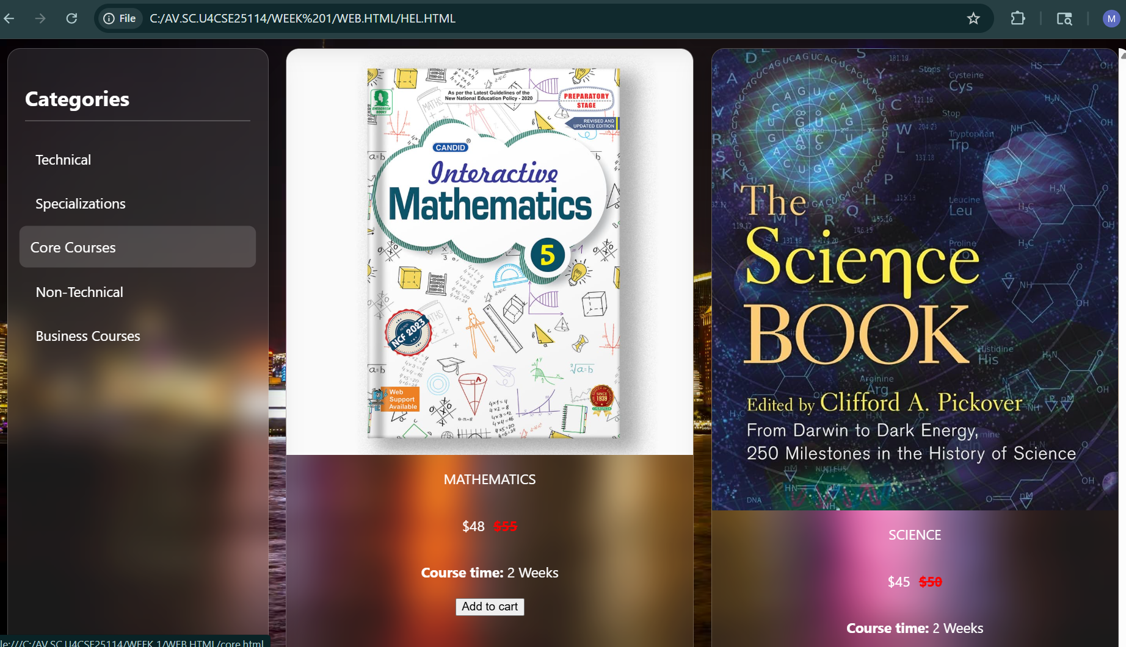
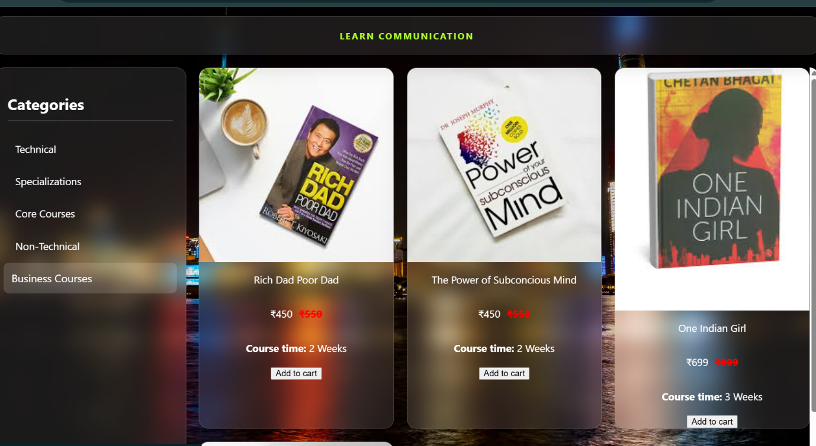
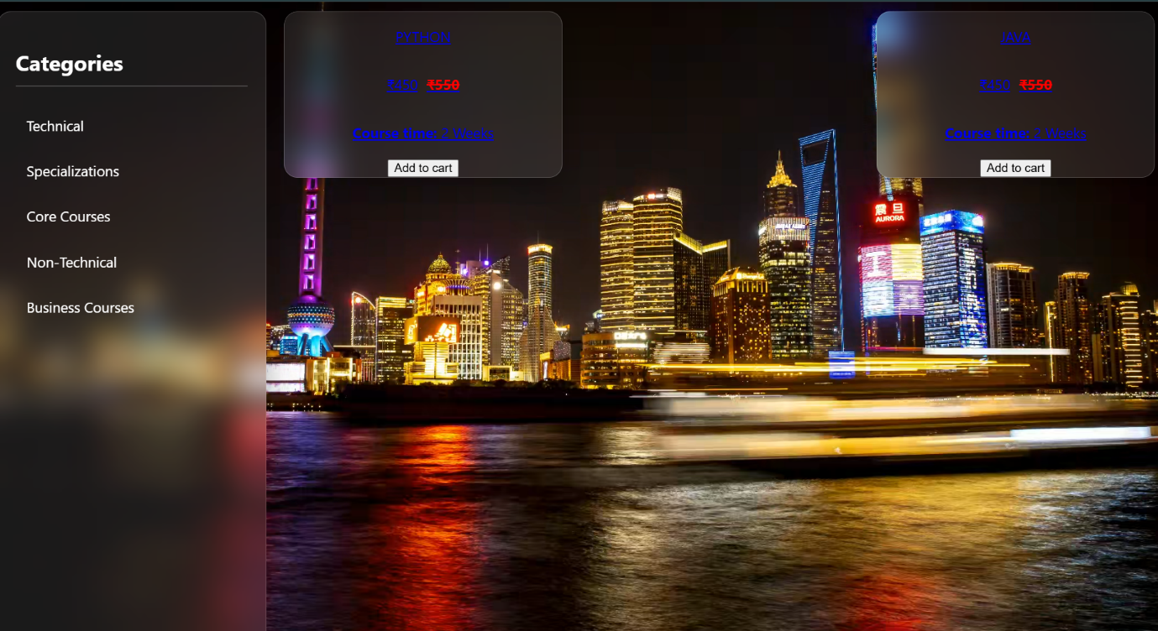
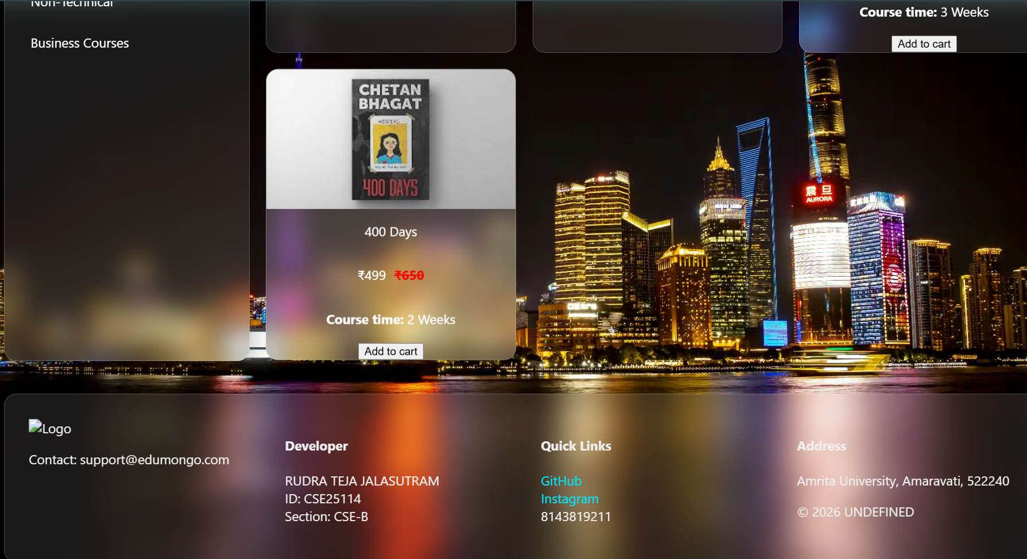

Explanation:
1. <!DOCTYPE html>Defines the document as HTML5, ensuring correct display in browsers.
2. <html> Root element that contains the entire webpage.
3. <head> Contains CSS styling used for designing the webpage layout.
4. <style> Used to write CSS for layout and design.
5. body Styling (Grid Layout)
display: grid; -- Creates a grid layout.
grid-template-rows -- Defines row sizes.
grid-template-columns -- Defines column sizes.
grid-template-areas -- Divides page into sections:
Header
Sale banner
Sidebar
Content
Footer
6. .header Section
Displays website title.
Styled with background color and centered text.
7. .sale Section (Scrolling Text)
Displays a scrolling sale message.
Uses @keyframes scroll for animation.
Moves text from right to left continuously.
8. @keyframes scroll
Defines movement of sale text.
translateX(-100%) -- Moves text horizontally.
9. .sidebar Section
Contains category links:
Electronics
Clothing
Books
Sports
Links use target="products" to open content in iframe.
10. .contents Section
Displays product pages inside the main page.
Default page loaded is electronics.html.
11. <iframe> Tag
Used to load other HTML pages inside the main page.
Changes content dynamically when user clicks categories.
12. .footer Section
Displays copyright information.

WEEK 7:
https://github.com/rudra25114/UID-LAB-AV.SC.U4CSE25114/tree/main
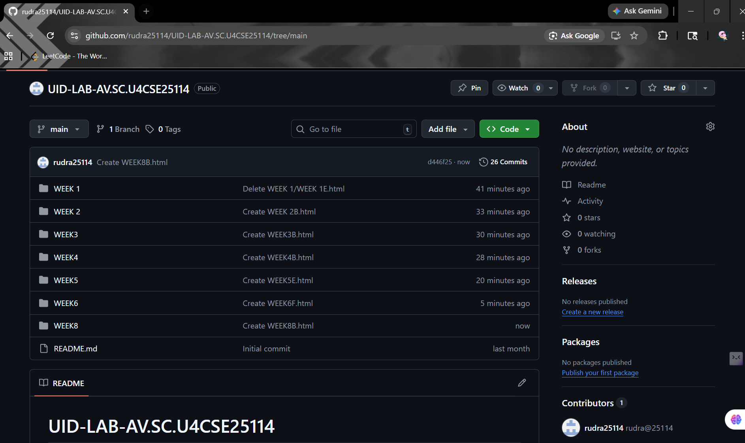

WEEK-8:
Aim: Create a webpage that displays a square that continuously rotates 360 degrees using CSS animations.
Program:
<!DOCTYPE html>
<html>
<head>
<title>Rotating Square</title>
<style>
body {
display: flex;
justify-content: center;
align-items: center;
height: 100vh;
}
.square {
width: 150px;
height: 150px;
background-color: GREEN;
animation: rotateBox 2s linear infinite;
}
@keyframes rotateBox {
from {
transform: rotate(0deg);
}
to {
transform: rotate(360deg);
}
} </style>
</head>
<body>
<div class="square"></div>
</body>
</html>
Output:
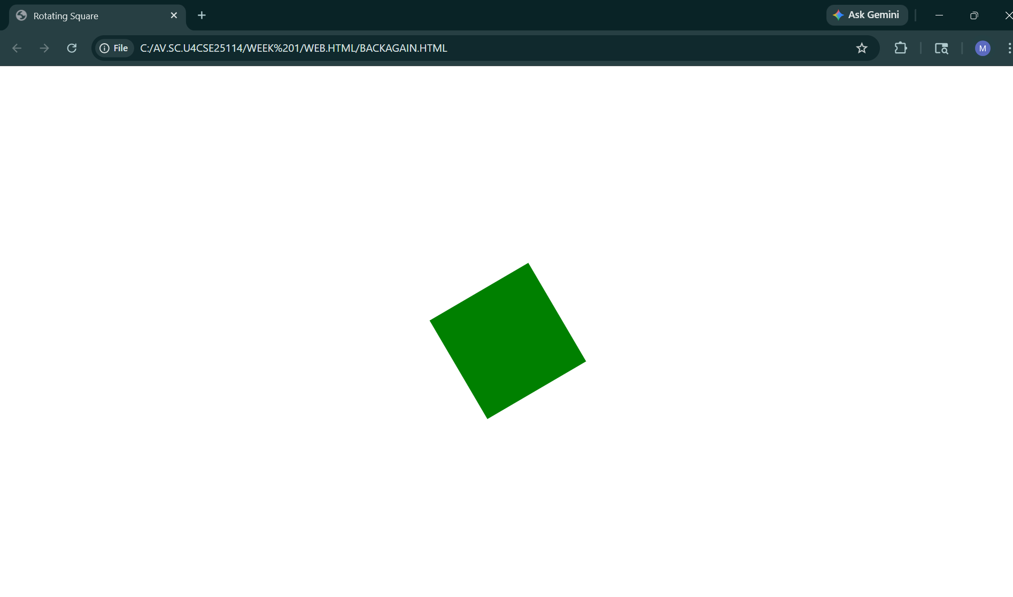
Expalnation:
1.<!DOCTYPE html>This declaration tells the browser that the document is written in HTML5. It ensures
proper rendering of the webpage.
2. <html>This is the root element of the HTML document. All other elements are placed inside this tag.
3. <head>The <head> section contains metadata and styling information for the webpage. It is not displayed
directly on the page.
4. <title>This defines the title of the webpage, which appears on the browser tab.
In this program, the title is "Rotating Square".
5. <style> This tag is used to write CSS (Cascading Style Sheets) inside the HTML document.
It controls the design and animation of the webpage.
6.display: flex; -- Enables Flexbox layout.
justify-content: center; -- Horizontally centers the content.
align-items: center; -- Vertically centers the content.
height: 100vh; -- Sets height equal to the full screen.
7.width & height -- Define the size of the square.
background-color -- Gives the square an orange color.
animation -- Applies animation:
rotateBox -- Name of animation
2s -- Duration (2 seconds)
linear -- Constant speed
infinite -- Repeats forever
8. @keyframes rotateBox -- Defines the animation steps.
from -- Starting position (0 degrees).
to -- Ending position (360 degrees).
transform: rotate() -- Rotates the square.
9. <body>This contains the visible content of the webpage.
10.<div class="square"></div>
Creates a square shape using a <div> element.
The class square applies all the CSS styling and animation.
Aim:Create a ball that moves up and down continuously using CSS animation.
Program:
<!DOCTYPE html>
<html>
<head>
<title>Bouncing Ball</title>
<style>
body {
display: flex;
justify-content: center;
align-items: center;
height: 100vh;
}
.ball {
width: 80px;
height: 80px;
background-color: YELLOW;
border-radius: 50%;
animation: bounce 1s ease-in-out infinite alternate;
}
@keyframes bounce {
from {
transform: translateY(0);
}
to {
transform: translateY(-200px);
}
} </style>
</head>
<body>
<div class="ball"></div>
</body>
</html>
Output:
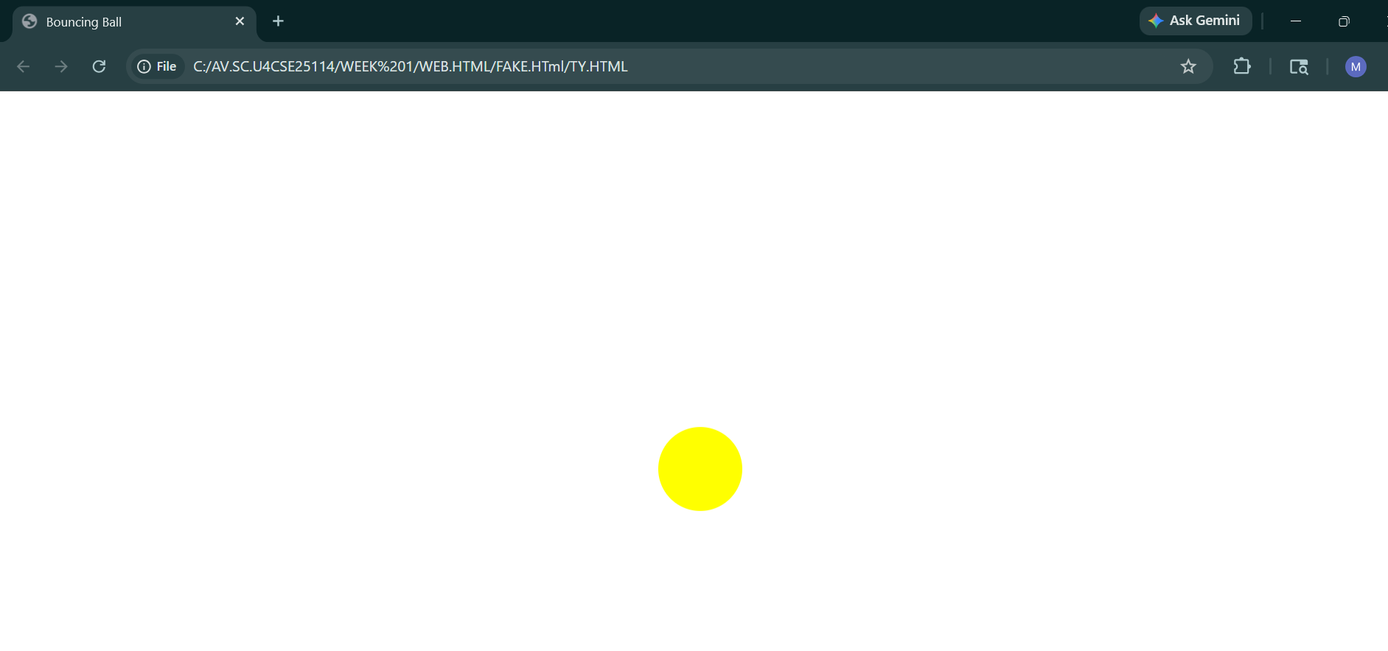
Explanation:
<!DOCTYPE html>This declaration defines the document as HTML5, ensuring the browser renders the page
correctly.
2. <html>This is the root element that contains the entire HTML document.
3. <head>The <head> section contains metadata and styling information. It is not visible on the webpage.
4. <title>This sets the title of the webpage shown on the browser tab,the titlefor this program is "Bouncing
Ball".
5. <style>This tag is used to write CSS code inside the HTML file. It controls the design and animation.
6. body Styling
display: flex; -- Enables Flexbox layout.
justify-content: center; -- Centers content horizontally.
align-items: center; -- Centers content vertically.
height: 100vh; -- Sets height equal to full screen.
7. .ball Class
width & height -- Define the size of the ball.
background-color -- Gives the ball a blue color.
border-radius: 50% -- Converts the square into a circle (ball shape).
animation:
bounce -- Name of animation
1s -- Duration (1 second)
ease-in-out -- Smooth speed (slow start and end)
infinite -- Repeats forever
alternate -- Moves back and forth (up and down).
8. @keyframes bounce
Defines the animation movement.
from -- Starting position (original position).
to -- Moves the ball 200px upwards.
transform: translateY() -- Moves the element vertically.
9.<body> Contains the visible content of the webpage.
10.<div class="ball"></div>
Creates the ball using a <div> element.
The class ball applies styling and animation.
Aim: Create a circle that moves horizontally and rotates at the same time.
Output:
Explanation:
1. <!DOCTYPE html>This declaration specifies that the document is written in HTML5, ensuring proper
rendering by the browser.
2. <html>This is the root element that contains all the HTML content of the webpage.
3. <head>The <head> section contains metadata and styling information. It is not displayed on the webpage.
4. <title>This sets the title of the webpage shown in the browser tab.
Here, the title is "Moving and Rotating Circle".
5. <style>This tag is used to include CSS code inside the HTML file. It controls the appearance and animation
of elements.
6. body Styling
display: flex; -- Enables Flexbox layout.
align-items: center; -- Vertically centers the circle.
height: 100vh; -- Sets height equal to the full screen.
7. .circle class
width & height -- Define the size of the circle.
background-color -- Gives the circle a green color.
border-radius: 50% -- Converts the square into a circle.
animation:
moveRotate -- Name of animation
3s -- Duration (3 seconds)
linear -- Constant speed
infinite -- Repeats continuously
8. @keyframes moveRotate
Defines the animation steps using percentages.
0% -- Starting state:
translateX(0) -- Circle starts from original position.
rotate(0deg) -- No rotation initially.
100% -- Ending state:
translateX(500px) -- Moves 500 pixels to the right.
rotate(360deg) -- Completes one full rotation.
9. <body> Contains the visible content of the webpage.
10. <div class="circle"></div>
Creates the circle using a <div> element.
The class circle applies styling and animation.

WEEK-9

Aim: Create an web page using HTML,CSS,Javascript based on the given conditions:
A .create a button for each program,based on the button clicked the corresponding program has to be executed and should display the output.

B .the logics for each button includes finding an even number,odd number,prime or not,factorial of a number,Armstrong or not

C .use appropriate designs to display the output(give the best UI)

Program:
<!DOCTYPE html>
<html>
<head>
<title>Number Analyzer</title>
<style>
body {
margin: 0;
font-family: 'Segoe UI', Tahoma, Geneva, Verdana, sans-serif;
background: linear-gradient(135deg, #667eea, #764ba2);
display: flex;
justify-content: center;
align-items: center;
height: 100vh;
color: #333;
}
.container {
background: white;
padding: 30px;
border-radius: 20px;
width: 350px;
box-shadow: 0 10px 30px rgba(0,0,0,0.2);
text-align: center;
}
h1 {
margin-bottom: 20px;
color: #444;
}
input {
width: 80%;
padding: 10px;
margin-bottom: 20px;
border-radius: 10px;
border: 1px solid #ccc;
font-size: 16px;
}
.buttons {
display: grid;
grid-template-columns: 1fr 1fr;
gap: 10px;
}
button {
padding: 10px;
border: none;
border-radius: 10px;
background: #667eea;
color: white;
font-size: 14px;
cursor: pointer;
transition: 0.3s;
}
button:hover {
background: #5a67d8;
transform: scale(1.05);
}
.output {
margin-top: 20px;
padding: 15px;
border-radius: 10px;
background: #f3f4f6;
min-height: 40px;
font-weight: bold;
color: #222;
}
</style>
</head>
<body>
<div class="container">
<h1>Number Analyzer</h1>
<input type="number" id="numberInput" placeholder="Enter a number">
<div class="buttons">
<button onclick="checkEven()">Even</button>
<button onclick="checkOdd()">Odd</button>
<button onclick="checkPrime()">Prime</button>
<button onclick="factorial()">Factorial</button>
<button onclick="checkArmstrong()" style="grid-column: span 2;">Armstrong</button>
</div>

<div class="output" id="output">Result will appear here</div>
</div>
<script>
function getInput() {
let num = document.getElementById("numberInput").value;
if (num === "") {
document.getElementById("output").innerText = "Please enter a number";
return null;
}
return parseInt(num);
}
function checkEven() {
let num = getInput();
if (num === null) return;
document.getElementById("output").innerText = (num % 2 === 0) ? num + " is Even" : num + " is NOT Even";
}
function checkOdd() {
let num = getInput();
if (num === null) return;
document.getElementById("output").innerText = (num % 2 !== 0) ? num + " is Odd" : num + " is NOT Odd";
}
function checkPrime() {
let num = getInput();
if (num === null) return;
if (num <= 1) {
document.getElementById("output").innerText = num + " is NOT Prime";
return;
}
for (let i = 2; i <= Math.sqrt(num); i++) {
if (num % i === 0) {
document.getElementById("output").innerText = num + " is NOT Prime";
return;
}
}
document.getElementById("output").innerText = num + " is Prime";
}
function factorial() {
let num = getInput();
if (num === null) return;
if (num < 0) {
document.getElementById("output").innerText = "Factorial not defined for negative numbers";
return;
}
let fact = 1;
for (let i = 1; i <= num; i++) {
fact *= i;
}
document.getElementById("output").innerText = "Factorial of " + num + " is " + fact;
}
function checkArmstrong() {
let num = getInput();
if (num === null) return;
let sum = 0;
let temp = num;
let digits = num.toString().length;
while (temp > 0) {
let digit = temp % 10;
sum += Math.pow(digit, digits);
temp = Math.floor(temp / 10);
}

document.getElementById("output").innerText = (sum === num) ? num + " is Armstrong" : num + " is NOT Armstrong";
}
</script>
</body>
</html>

Output:

Explanation:
1. HTML Structure

<html>, <head>, <body>: Basic structure of the webpage.
<title>: Sets the title as “Number Analyzer”.
<div class="container">: Main box that holds all elements.
<h1>: Displays the heading.
<input>: Allows user to enter a number.
<button>: Triggers different operations:
- Even
- Odd
- Prime
- Factorial
- Armstrong
<div id="output">: Displays the result.

2. CSS Styling

Body Styling
Gradient background (linear-gradient)
Center alignment using flexbox.

Container
White box with padding and rounded corners
Shadow effect for better UI

Buttons
Styled with color, rounded edges, and hover effect
Hover effect enlarges button slightly
Input Field
Styled with padding and rounded borders

Output Box
Displays results with highlighted background

3. JavaScript Functionality
JavaScript is used to implement the logic.

3.1 getInput() Function
Fetches the value entered by the user.
Checks if input is empty.
Displays message if no input is given.
Converts input into an integer using parseInt().

3.2 checkEven() Function
Checks whether the number is divisible by 2.
If num % 2 === 0 → Even
Else → Not Even

3.3 checkOdd() Function
Checks whether the number is not divisible by 2.
If num % 2 !== 0 → Odd
Else → Not Odd

3.4 checkPrime() Function
Checks whether a number is prime.
Conditions:
Numbers ≤ 1 are not prime
Loop runs from 2 to √num
If divisible → Not Prime
Else → Prime

3.5 factorial() Function
Calculates factorial of a number.
Factorial formula:
n! = 1 × 2 × 3 × ... × n
Uses a loop from 1 to n.
Negative numbers are not allowed.

3.6 checkArmstrong() Function
Checks whether a number is an Armstrong number.
Count number of digits
Extract each digit
Raise each digit to power of total digits
Add all values
If sum equals original number → Armstrong
Else → Not Armstrong

4. Working Principle
User enters a number in the input field.
User clicks any button.
Corresponding JavaScript function is called.
Result is displayed in the output box.

WEEK-10
Aim: Write a Javascript conditional statement to find the Sign of Product of three numbers using functions. Display an alert box with the specified sign.

Program:
<!DOCTYPE html>
<html>
<head>
<title>Sign of Product</title>
<style>
body {
margin: 0;
font-family: 'Segoe UI', Tahoma, Geneva, Verdana, sans-serif;
background: linear-gradient(135deg, #dfe9f3, #ffffff);
display: flex;
justify-content: center;
align-items: center;
height: 100vh;
}
.container {
background: #ffffff;
padding: 30px;
border-radius: 20px;
width: 320px;
text-align: center;
box-shadow: 0 10px 25px rgba(0,0,0,0.15);
}
h2 {
margin-bottom: 20px;
color: #2c3e50;
}
input {
width: 85%;
padding: 10px;
margin: 8px 0;
border-radius: 10px;
border: 1px solid #ccc;
font-size: 15px;
outline: none;
}
input:focus {
border-color: #4a90e2;
box-shadow: 0 0 5px rgba(74,144,226,0.4);
}
button {
margin-top: 15px;
padding: 10px 20px;
border: none;
border-radius: 10px;
background: #4a90e2;
color: white;
font-size: 15px;
cursor: pointer;
transition: 0.3s;
}
button:hover {
background: #357abd;
transform: scale(1.05);
}
</style>
<script>
function findSign() {
let a = parseFloat(document.getElementById("num1").value);
let b = parseFloat(document.getElementById("num2").value);
let c = parseFloat(document.getElementById("num3").value);

if (isNaN(a) || isNaN(b) || isNaN(c)) {
alert("Please enter all three numbers!");
return;
}

let product = a * b * c;

if (product > 0) {
alert("The sign is + (Positive)");
} else if (product < 0) {
alert("The sign is - (Negative)");
} else {
alert("The product is 0");
}
}
</script>
</head>
<body>
<div class="container">
<h2>Sign of Product</h2>
<input type="number" id="num1" placeholder="Enter first number">
<input type="number" id="num2" placeholder="Enter second number">
<input type="number" id="num3" placeholder="Enter third number">
<button onclick="findSign()">Check Sign</button>
</div>
</body>
</html>

Output:

Explanation:
1. HTML Structure (User Interface)
The title is “Sign of Product”
A centered container box holds all elements
Inside the container:
<h2> → Displays heading “Sign of Product”
3 <input> fields → User enters three numbers
<button> → Calls the function findSign() when clicked
2. CSS Styling (Appearance)
Background → Light gradient (#dfe9f3 → white)
Container:
White card style
Rounded corners
Soft shadow
Inputs:
Rounded edges
Highlight effect when focused (blue glow)
Button:
Blue color
Hover effect:
Slight zoom
Darker shade

Gives a clean and modern UI.
3. JavaScript Function (Main Logic)
Function: findSign()
This runs when the user clicks Check Sign
Step 1: Read Input Values
let a = parseFloat(document.getElementById("num1").value);
Gets values from input fields (num1, num2, num3)
Converts them into decimal numbers using parseFloat()
Step 2: Validate Input
if (isNaN(a) || isNaN(b) || isNaN(c))
Checks if any input is not a number
isNaN() → returns true if value is invalid
If any field is empty or invalid:
alert("Please enter all three numbers!");
return;
Shows alert
Stops execution using return
Step 3: Calculate Product
let product = a * b * c;
Multiplies all three numbers
Step 4: Determine Sign
if (product > 0)
If product is positive → shows +
else if (product < 0)
If product is negative → shows -
else
If product = 0 → shows "The product is 0"
Step 5: Display Result
Uses alert() to show result:
Positive → "The sign is + (Positive)"
Negative → "The sign is - (Negative)"
Zero → "The product is 0"

4. How the Logic Works
User enters 3 numbers
Clicks Check Sign
Program:
Validates input
Multiplies numbers
Checks result sign
Displays output
5. Important Concepts Used
DOM access → getElementById()
Type conversion → parseFloat()
Validation → isNaN()
Conditional statements → if-else
Arithmetic → multiplication
Output → alert()
6. Key Concept
The sign of a product depends on negative numbers:
Even number of negative values → Positive result
Odd number of negative values → Negative result
Any number = 0 → Product is 0

Aim: Write a javascript conditional statement to sort three numbers using functions.
Display an alert box to show the result.

Program:
<!DOCTYPE html>
<html>
<head>
<title>Sort Three Numbers</title>
<style>
body {
margin: 0;
font-family: 'Segoe UI', Tahoma, Geneva, Verdana, sans-serif;
background: linear-gradient(135deg, #8e2de2, #ff6a00);
display: flex;
justify-content: center;
align-items: center;
height: 100vh;
color: white;
}
.container {
background: rgba(0, 0, 0, 0.6);
padding: 30px;
border-radius: 20px;
width: 320px;
text-align: center;
box-shadow: 0 10px 25px rgba(0,0,0,0.5);
}
h2 {
margin-bottom: 20px;
}
input {
width: 85%;
padding: 10px;
margin: 8px 0;
border-radius: 10px;
border: none;
background: rgba(255,255,255,0.2);
color: white;
outline: none;
transition: 0.3s;
}
input::placeholder {
color: #ddd;
}
input:focus {
background: rgba(255,255,255,0.3);
box-shadow: 0 0 8px rgba(255,255,255,0.5);
}
button {
margin-top: 15px;
padding: 10px 20px;
border: none;
border-radius: 10px;
background: linear-gradient(135deg, #ff6a00, #ee0979);
color: white;
font-size: 15px;
cursor: pointer;
transition: 0.3s;
}
button:hover {
transform: scale(1.08);
box-shadow: 0 0 15px rgba(255,106,0,0.7);
}
</style>
<script>
function sortNumbers() {
let a = parseFloat(document.getElementById("num1").value);
let b = parseFloat(document.getElementById("num2").value);
let c = parseFloat(document.getElementById("num3").value);
if (isNaN(a) || isNaN(b) || isNaN(c)) {
alert("Please enter all three numbers!");
return;
}
let arr = [a, b, c];
arr.sort(function(x, y) {
return x - y;
});
alert("Sorted numbers (Ascending): " + arr.join(", "));
}
</script>
</head>
<body>
<div class="container">
<h2> Sort Three Numbers</h2>
<input type="number" id="num1" placeholder="Enter first number">
<input type="number" id="num2" placeholder="Enter second number">
<input type="number" id="num3" placeholder="Enter third number">
<button onclick="sortNumbers()">Sort Numbers</button>
</div>
</body>
</html>

Output:

Explantion:
1. Getting input values
let a = parseFloat(document.getElementById("num1").value);
Reads numbers from input boxes
parseFloat() converts them into numbers
2. Checking if inputs are valid
if (isNaN(a) || isNaN(b) || isNaN(c))
Ensures all fields are filled
If not → shows alert and stops
3. Storing numbers in array
let arr = [a, b, c];
Puts all numbers into one array
Makes sorting easier
4. Sorting logic (most important ⭐)
arr.sort(function(x, y) {
return x - y;
});
Sorts numbers in ascending order
x - y ensures proper numeric sorting
5. Displaying result
alert("Sorted numbers (Ascending): " + arr.join(", "));
Shows sorted numbers
join(", ") formats output nicely

Aim: Write a javascript conditional statement to find the largest of five numbers using function and onclick event.Display an alert box to show the result.

Program:
<!DOCTYPE html>
<html>
<head>
<title>Find Largest Number</title>
<style>
body {
margin: 0;
font-family: 'Segoe UI', sans-serif;
background: linear-gradient(135deg, #36d1dc, #5b86e5);
height: 100vh;
display: flex;
justify-content: center;
align-items: center;
}
.container {
background: white;
padding: 30px;
border-radius: 15px;
width: 320px;
text-align: center;
box-shadow: 0 10px 25px rgba(0,0,0,0.2);
}
h2 {
margin-bottom: 20px;
color: #333;
}
input {
width: 90%;
padding: 10px;
margin: 6px 0;
border-radius: 8px;
border: 1px solid #ccc;
font-size: 16px;
}
button {
margin-top: 15px;
padding: 12px 20px;
border: none;
border-radius: 25px;
background: linear-gradient(45deg, #ff7e5f, #feb47b);
color: white;
font-size: 16px;
cursor: pointer;
transition: 0.3s;
}
button:hover {
background: linear-gradient(45deg, #feb47b, #ff7e5f);
transform: scale(1.05);
}
</style>
</head>
<body>
<div class="container">
<h2>Largest of 5 Numbers</h2>
<input type="number" id="n1" placeholder="Enter number 1">
<input type="number" id="n2" placeholder="Enter number 2">
<input type="number" id="n3" placeholder="Enter number 3">
<input type="number" id="n4" placeholder="Enter number 4">
<input type="number" id="n5" placeholder="Enter number 5">
<button onclick="findLargest()">Find Largest</button>
</div>
<script>
function findLargest() {
let a = Number(document.getElementById("n1").value);
let b = Number(document.getElementById("n2").value);
let c = Number(document.getElementById("n3").value);
let d = Number(document.getElementById("n4").value);
let e = Number(document.getElementById("n5").value);
let largest;
if (a >= b && a >= c && a >= d && a >= e) {
largest = a;
} else if (b >= a && b >= c && b >= d && b >= e) {
largest = b;
} else if (c >= a && c >= b && c >= d && c >= e) {
largest = c;
} else if (d >= a && d >= b && d >= c && d >= e) {
largest = d;
} else {
largest = e;
}
alert("The largest number is: " + largest);
}
</script>
</body>
</html>

Output:

Explanation:
1. HTML Structure (User Interface)
The page title is “Find Largest Number”
A centered container box is created using <div class="container">
Inside the container:
<h2> → Displays heading “Largest of 5 Numbers”
5 <input> fields → User enters five numbers
<button> → Calls the function findLargest() when clicked

2. CSS Styling (Design)
Background → Blue gradient (#36d1dc → #5b86e5)
Container:
White card style
Rounded corners
Shadow for depth
Inputs:
Clean spacing and rounded edges
Button:
Gradient color (orange tones)
Hover effect:
Color reverses
Slight zoom animation
This makes the UI modern and interactive.

3. JavaScript Function (Core Logic)
Function: findLargest()
This function runs when the user clicks the button.
Step 1: Get Input Values
let a = Number(document.getElementById("n1").value);
Reads values from input fields (n1 to n5)
Converts them into numbers using Number()
Prevents string comparison errors
Step 2: Declare Variable
let largest;
A variable to store the largest number
Step 3: Compare Numbers Using Conditions
if (a >= b && a >= c && a >= d && a >= e)
Checks if a is greater than or equal to all others
If true → a is the largest
Then similar checks are done for:
b
c
d
If none of those are true:
else {
largest = e;
}
Then e is automatically the largest
Step 4: Display Result
alert("The largest number is: " + largest);
Shows a popup message with the result
4. How the Logic Works (Flow)
User enters 5 numbers
Clicks Find Largest
Program:
Reads all values
Compares them using if-else
Finds the biggest number
Displays result using alert
5. Important Concepts Used
DOM access → getElementById()
Type conversion → Number()
Logical operators → && (AND)
Conditional statements → if-else
Output method → alert()
6. Key Point to Understand
Condition like:
a >= b && a >= c && a >= d && a >= e
means:
“a must be greater than or equal to every other number”
Only then it is considered the largest.

Aim: write a javascript for loop that will iterate from 0 to 15. For each iteration, it will check if the Current number is odd or even, and display a message to the screen.

Program:

<!DOCTYPE html>
<html>
<head>
<title>Odd or Even Checker</title>
<style>
body {
font-family: Arial, sans-serif;
background: linear-gradient(135deg, #667eea, #764ba2);
color: white;
text-align: center;
padding: 40px;
}
h2 {
margin-bottom: 20px;
}
button {
padding: 10px 20px;
font-size: 16px;
border: none;
border-radius: 20px;
background: #ff7e5f;
color: white;
cursor: pointer;
}
button:hover {
background: #feb47b;
}
#output {
margin-top: 20px;
text-align: left;
display: inline-block;
background: rgba(255,255,255,0.1);
padding: 15px;
border-radius: 10px;
}
</style>
</head>
<body>
<h2>Odd or Even from 0 to 15</h2>
<button onclick="checkNumbers()">Check Numbers</button>
<div id="output"></div>
<script>
function checkNumbers() {
let result = "";
for (let i = 0; i <= 15; i++) {
if (i % 2 === 0) {
result += i + " is Even<br>";
} else {
result += i + " is Odd<br>";
}
}
document.getElementById("output").innerHTML = result;
}
</script>
</body>
</html>

Output:

Explanation:
1. Button triggers function
<button onclick="checkNumbers()">Check Numbers</button>
When clicked → runs checkNumbers()

2. Loop (main logic )
for (let i = 0; i <= 15; i++)
Starts from 0
Runs until 15
Increases by 1 each time

3. Check Odd or Even
if (i % 2 === 0)
% = remainder operator
If remainder is 0 → Even
Else → Odd

4. Store result
result += i + " is Even<br>";
Adds each result to a string
<br> moves to next line

5. Display output
document.getElementById("output").innerHTML = result;
Shows all results inside the page

Aim:Write a javascript program to read 6 subjects marks from the student then compute the average marks of the student.Then this average is used to determine the corresponding grade.
Range Grade
<60 F
<70 D
<80 C
<90 B
<100 A

Program:
<!DOCTYPE html>
<html>
<head>
<title>Student Grade Calculator</title>

<style>
body {
font-family: 'Segoe UI', sans-serif;
background: linear-gradient(135deg, #11998e, #38ef7d);
display: flex;
justify-content: center;
align-items: center;
height: 100vh;
}

.container {
background: white;
padding: 25px;
border-radius: 15px;
text-align: center;
width: 320px;
box-shadow: 0 10px 25px rgba(0,0,0,0.2);
}

h2 {
margin-bottom: 15px;
}

input {
width: 90%;
padding: 10px;
margin: 5px 0;
border-radius: 8px;
border: 1px solid #ccc;
}

button {
margin-top: 15px;
padding: 12px 20px;
border: none;
border-radius: 25px;
background: linear-gradient(45deg, #ff6a00, #ee0979);
color: white;
cursor: pointer;
font-size: 16px;
transition: 0.3s;
}

button:hover {
transform: scale(1.05);
}

#result {
margin-top: 20px;
font-size: 18px;
font-weight: bold;
}

.A { color: green; }
.B { color: #2ecc71; }
.C { color: orange; }
.D { color: #e67e22; }
.F { color: red; }
</style>
</head>

<body>

<div class="container">
<h2>Grade Calculator</h2>

<input type="number" id="m1" placeholder="Subject 1">
<input type="number" id="m2" placeholder="Subject 2">
<input type="number" id="m3" placeholder="Subject 3">
<input type="number" id="m4" placeholder="Subject 4">
<input type="number" id="m5" placeholder="Subject 5">
<input type="number" id="m6" placeholder="Subject 6">

<button onclick="calculateGrade()">Calculate</button>

<div id="result"></div>
</div>

<script>
function calculateGrade() {

let m1 = Number(document.getElementById("m1").value);
let m2 = Number(document.getElementById("m2").value);
let m3 = Number(document.getElementById("m3").value);
let m4 = Number(document.getElementById("m4").value);
let m5 = Number(document.getElementById("m5").value);
let m6 = Number(document.getElementById("m6").value);

let avg = (m1 + m2 + m3 + m4 + m5 + m6) / 6;

let grade;

if (avg < 60) {
grade = "F";
} else if (avg < 70) {
grade = "D";
} else if (avg < 80) {
grade = "C";
} else if (avg < 90) {
grade = "B";
} else if (avg < 100) {
grade = "A";
} else {
grade = "Invalid";
}

let resultDiv = document.getElementById("result");

resultDiv.innerHTML =
"Average: " + avg.toFixed(2) + "<br>Grade: " + grade;

resultDiv.className = grade; // apply color
}
</script>

</body>
</html>

Explanation:

1. HTML Structure
The page title is “Student Grade Calculator”.
Inside <body>, there is a container box that holds everything.
Inside the container:
<h2> → Displays the heading "Grade Calculator"
Six <input> fields → Used to enter marks for 6 subjects
<button> → Calls the function calculateGrade() when clicked
<div id="result"> → Displays the output (average + grade)

2. CSS Styling (How it looks)
The background is a green gradient (#11998e → #38ef7d)
The .container:
White background
Rounded corners
Shadow effect (card style)
Inputs:
Rounded edges
Spacing for clean layout
Button:
Gradient color (orange → pink)
Hover effect (slight zoom)
Grade colors:
A → Green
B → Light green
C → Orange
D → Dark orange
F → Red

These classes are later applied dynamically using JavaScript.

3. JavaScript Function (Main Logic)
Function: calculateGrade()
This runs when the button is clicked.

Step 1: Read Input Values
let m1 = Number(document.getElementById("m1").value);
Gets value from each input field (m1 to m6)
Converts it into a number using Number()
Prevents string-related errors

Step 2: Calculate Average
let avg = (m1 + m2 + m3 + m4 + m5 + m6) / 6;
Adds all 6 subject marks
Divides by 6 to get the average

Step 3: Determine Grade
Range Grade
<60 F
<70 D
<80 C
<90 B
<100 A

Step 4: Display Result
resultDiv.innerHTML =
"Average: " + avg.toFixed(2) + "<br>Grade: " + grade;
Shows:
Average (rounded to 2 decimal places)
Grade
<br> adds a new line

Step 5: Apply Color Based on Grade
resultDiv.className = grade;
Dynamically assigns class:
If grade = "A" → class A is applied
If grade = "F" → class F is applied
This changes the text color automatically

Week -11
11.A)Aim: A website requires users to enter a username. The system should display a message while typing if the username is less than 5 characters.
Program :
<html>
<head>
<title>Username Check</title>
<style>
body {
margin:0;
font-family: Arial;
background: linear-gradient(120deg,#2980b9,#6dd5fa);
display:flex;
justify-content:center;
align-items:center;
height:100vh;
}
.card {
background:white;
padding:30px;
border-radius:12px;
width:300px;
box-shadow:0 10px 25px rgba(0,0,0,0.2);
}
input { width:100%; padding:10px; margin-top:10px; }
</style>
</head>
<body>
<div class="card">
<h2>Username</h2>
<input type="text" id="username" placeholder="Enter username" onkeyup="checkUsername()">
<p id="msg"></p>
</div>
<script>
function checkUsername() {
let val=document.getElementById("username").value;
let msg=document.getElementById("msg");
if(val.length<5){ msg.innerText="Minimum 5 characters required"; msg.style.color="red"; }
else{ msg.innerText="Valid username"; msg.style.color="green"; }
}
</script>
</body>
</html>

Output :
Explanation :
<!DOCTYPE html> : the <!DOCTYPE html> element tells the browser that this is an HTML5 document
<html> : the <html> element is the root element of the web page all elements are written inside this
<head> : the <head> element contains meta information like title and styles
<title> : the <title> element specifies the name of the web page it appears on the browser tab
<style> : the <style> element is used to write CSS for designing the page
body : the body selector is used to style the whole page here flex is used to center the card layout
.card : this class is used to create a box container with padding shadow and rounded corners
input : the <input> element is used to take user input for username
<p> : the <p> element is used to display validation message
<script> : the <script> element is used to write JavaScript code
function : used to define a block of code that performs username validation
getElementById() : used to access username input and message element
.value : used to get value from input box
length : used to check number of characters entered
if condition : used to check if username is less than 5 characters
innerText : used to display message on screen
style.color : used to change text color based on validation
11.B)Aim : A registration form should validate email format before submission. If invalid, the form should not be submitted.
Program:
<html>
<head>
<title>Email Validation</title>
<style>
body{margin:0;font-family:Arial;background:linear-gradient(120deg,#ff6a00,#ee0979);display:flex;justify-content:center;align-items:center;height:100vh;}
.card{background:white;padding:30px;border-radius:12px;width:320px;box-shadow:0 10px 25px rgba(0,0,0,0.2);}
input,button{width:100%;padding:10px;margin-top:10px;}
button{background:#ee0979;color:white;border:none;cursor:pointer;}
</style>
</head>
<body>
<div class="card">
<h2>Email Check</h2>
<form onsubmit="return validateEmail()">
<input type="text" id="email" placeholder="Enter Email">
<button type="submit">Submit</button>
</form>
</div>
<script>
function validateEmail(){
let email=document.getElementById("email").value;
let pattern=/^[^ ]+@[^ ]+\.[a-z]{2,3}$/;
if(pattern.test(email)){
alert("Email is valid");
return true;
}else{
alert("Invalid Email");
return false;
}
}
</script>
</body>
</html>

Output :
Explanation :
<!DOCTYPE html> : the <!DOCTYPE html> element tells the browser that this is an HTML5 document
<html> : the <html> element is the root element of the web page
<head> : contains title and styles
<title> : displays page name on browser tab
<style> : used to design the page with gradient background and card layout
form : the <form> element is used to collect user input
input : used to take email input from user
button : used to submit the form
onsubmit : used to call JavaScript function when form is submitted
<script> : used to write JavaScript validation logic
function : defines email validation logic
getElementById() : used to access email input
.value : gets the email value entered by user
pattern : regular expression used to check valid email format
test() : checks if email matches pattern
if condition : checks whether email is valid or not
alert() : used to display popup message for valid or invalid email
return false : prevents form submission if invalid
return true : allows form submission if valid
11.C)Aim: A system should check password strength while typing and display whether it is weak or strong.
Program :
<html>
<head>
<title>Password Strength</title>
<style>
body{margin:0;font-family:Arial;background:linear-gradient(120deg,#00b09b,#96c93d);display:flex;justify-content:center;align-items:center;height:100vh;}
.card{background:white;padding:30px;border-radius:12px;width:350px;box-shadow:0 10px 25px rgba(0,0,0,0.2);}
input{width:100%;padding:10px;margin-top:10px;}
</style>
</head>
<body>
<div class="card">
<h2>Password Strength</h2>
<p><b>Rules:</b><br>• At least 6 characters<br>• One uppercase letter<br>• One special symbol</p>
<input type="password" id="pass" onkeyup="checkStrength()">
<p id="msg"></p>
</div>
<script>
function checkStrength(){
let pass=document.getElementById("pass").value;
let msg=document.getElementById("msg");
let strong=/^(?=.*[A-Z])(?=.*[!@#$%^&*]).{6,}$/;
if(strong.test(pass)){
msg.innerText="Strong Password";
msg.style.color="green";
}else{
msg.innerText="Weak Password";
msg.style.color="red";
}
}
</script>
</body>
</html>
Output:
Explanation:
<!DOCTYPE html> : defines HTML5 document
<html> : root element of webpage
<head> : contains title and style
<title> : shows page title
<style> : used for page design and layout styling
body : used to center the card with gradient background
.card : used to create container box
<p> : used to display password rules
input : used to enter password
<script> : contains JavaScript logic
function : defines password checking logic
getElementById() : used to access password input and message
.value : gets password entered by user
pattern : regular expression used to check password strength
(?=.*[A-Z]) : ensures at least one uppercase letter
(?=.*[!@#$%^&*]) : ensures at least one special symbol
.{6,} : ensures minimum 6 characters
test() : checks if password matches pattern
if condition : checks strong or weak password
innerText : displays result message
style.color : changes text color based on strength
11.D)Aim : A form should validate a mobile number when the user leaves the input field. The number must be exactly 10 digits
Program :
<!DOCTYPE html>
<html>
<head>
<title>Mobile Validation</title>
<style>
body{margin:0;font-family:Arial;background:linear-gradient(120deg,#fc466b,#3f5efb);display:flex;justify-content:center;align-items:center;height:100vh;}
.card{background:white;padding:30px;border-radius:12px;width:320px;box-shadow:0 10px 25px rgba(0,0,0,0.2);}
input{width:100%;padding:10px;margin-top:10px;}
</style>
</head>
<body>
<div class="card">
<h2>Mobile & Password</h2>
<input type="text" id="mobile" placeholder="Enter Mobile" onblur="validateMobile()">
<input type="password" id="pass" placeholder="Enter Password" onkeyup="checkPass()">
<p id="msg"></p>
</div>
<script>
function validateMobile(){
let num=document.getElementById("mobile").value;
let msg=document.getElementById("msg");
let pattern=/^[0-9]{10}$/;
if(pattern.test(num)) msg.innerText="Valid mobile";
else msg.innerText="Invalid mobile";
}
function checkPass(){
let pass=document.getElementById("pass").value;
let strong=/^(?=.*[A-Z])(?=.*[!@#$%^&*]).{6,}$/;
let msg=document.getElementById("msg");
if(strong.test(pass)) msg.innerText="Strong Password";
else msg.innerText="Weak Password";
}
</script>
</body>
</html>

Output :
Explanation :
<!DOCTYPE html> : defines HTML5 document
<html> : root element of page
<head> : contains title and styles
<title> : sets page title
<style> : used for UI design and layout
body : centers the content using flexbox
.card : used as container box
input : used to take mobile number and password input
onblur : triggers validation when user leaves mobile input field
onkeyup : triggers password validation while typing
<script> : contains JavaScript code
function : defines validation logic
getElementById() : used to access input fields and message
.value : gets input values
pattern : regular expression for mobile validation
^[0-9]{10}$ : ensures exactly 10 digits
test() : checks if mobile number is valid
if condition : checks valid or invalid mobile
password pattern : same as strong password rule
innerText : displays result message
11.E)Aim: Design an HTML page, such that the registration form must validate:
Name (not empty)
Email (valid format)
Password (minimum 6 characters)
Program :
<html>
<head>
<title>Register</title>
<style>
body{margin:0;font-family:Arial;background:linear-gradient(120deg,#141e30,#243b55);display:flex;justify-content:center;align-items:center;height:100vh;color:white;}
.card{background:white;color:black;padding:30px;border-radius:12px;width:350px;box-shadow:0 10px 25px rgba(0,0,0,0.3);}
input,button{width:100%;padding:10px;margin-top:10px;}
button{background:#243b55;color:white;border:none;cursor:pointer;}
</style>
</head>
<body>
<div class="card">
<h2>Registration Form</h2>
<form onsubmit="return validateForm()">
<input type="text" id="name" placeholder="Name">
<input type="text" id="email" placeholder="Email">
<input type="password" id="pass" placeholder="Password">
<button type="submit">Register</button>
<p id="msg"></p>
</form>
</div>
<script>
function validateForm(){
let name=document.getElementById("name").value;
let email=document.getElementById("email").value;
let pass=document.getElementById("pass").value;
let msg=document.getElementById("msg");
let emailPattern=/^[^ ]+@[^ ]+\.[a-z]{2,3}$/;
let strong=/^(?=.*[A-Z])(?=.*[!@#$%^&*]).{6,}$/;

if(name===""){ msg.innerText="Name required"; return false; }
if(!emailPattern.test(email)){ msg.innerText="Invalid email"; return false; }
if(!strong.test(pass)){ msg.innerText="Weak password"; return false; }
alert("Registration Successful");
return true;
}
</script>
</body>
</html>

Output :
Explanation :
<!DOCTYPE html> : defines HTML5 document
<html> : root element of webpage
<head> : contains title and style
<title> : sets name of webpage
<style> : used to design form layout and appearance
body : centers form with gradient background
.card : used to create form container
form : used to collect user data
input : used to take name email and password
button : used to submit form
onsubmit : triggers validation before submission
<script> : contains JavaScript validation logic
function : defines form validation process
getElementById() : used to access form fields
.value : gets input values
emailPattern : checks valid email format
strong pattern : checks password strength
if condition : checks name not empty
if condition : checks email format
if condition : checks password rules
alert() : shows success message when all validations pass
return false : prevents submission if invalid
return true : allows submission if valid
innerText : displays error messages

Week-12
12). Aim : To show the steps involved in installing and using Electron.
Procedure :
Step – 1 : Install node js from the website “Node.js”.

Step – 2 : Create folder with your liked name on desktop and open that folder in V.S. code .Now open terminal in that folder and type this command : “ npm init –y ”, on which will be installed package named “ package.json ” . Now , another command :“ npm install electron --save-dev", on which you will get “ package-lock.json ” and “node-modules”.

Step-3 : Now let us understand about this with an example of creating a mini calculator .Write the required codes for this project to be done in the folder after doing those above discussed steps.

index.html code

main.js code

renderer.js code :

Step-4 : Now in package.json , change the ‘main’ value as ‘main.js’ and ‘start’ one as ‘electron .’ as shown.

Step-5 : You are all done .Only thing left is to give “npm start” command in terminal for output.
OUTPUT

